Copyrighted material licensed to Toni Bonàs on 2026-05-06 for licensee's use only.
ROAD SURFACE AND ROAD MARKING REFLECTION CHARACTERISTICS
CIE 144:2001
UDC:
535.312
535.361.2
628.971.6
628.971.85:629.113.06
Descriptor: Regular reflection
Diffuse reflection. Scattered reflection Street lighting
Lighting by motor vehicle lamps
No further reproduction or networking is permitted. Distributed by Accuris, https://accuristech.com.
ISBN 978 3 901906 12 1





THE INTERNATIONAL COMMISSION ON ILLUMINATION
The International Commission on Illumination (CIE) is an organisation devoted to international co-operation and exchange of information among its member countries on all matters relating to the art and science of lighting. Its membership consists of the National Committees in 38 countries and one geographical area and of 8 associate members.
The objectives of the CIE are :
- To provide an international forum for the discussion of all matters relating to the science, technology and art in the fields of light and lighting and for the interchange of information in these fields between countries.
- To develop basic standards and procedures of metrology in the fields of light and lighting.
- To provide guidance in the application of principles and procedures in the development of international and national standards in the fields of light and lighting.
- To prepare and publish standards, reports and other publications concerned with all matters relating to the science, technology and art in the fields of light and lighting.
- To maintain liaison and technical interaction with other international organisations concerned with matters related to the science, technology, standardisation and art in the fields of light and lighting.
The work of the CIE is carried on by seven Divisions each with about 20 Technical Committees. This work covers subjects ranging from fundamental matters to all types of lighting applications. The standards and technical reports developed by these international Divisions of the CIE are accepted throughout the world.
A plenary session is held every four years at which the work of the Divisions and Technical Committees is reviewed, reported and plans are made for the future. The CIE is recognised as the authority on all aspects of light and lighting. As such it occupies an important position among international organisations.

LA COMMISSION INTERNATIONALE DE L'ECLAIRAGE
La Commission Internationale de l'Eclairage (CIE) est une organisation qui se donne pour but la coopération internationale et l'échange d'informations entre les Pays membres sur toutes les questions relatives à l'art et à la science de l'éclairage. Elle est composée de Comités Nationaux représentant 38 pays plus un territoire géographique, et de 8 membres associés.
Les objectifs de la CIE sont :
- De constituer un centre d'étude international pour toute matière relevant de la science, de la technologie et de l'art de la lumière et de l'éclairage et pour l'échange entre pays d'informations dans ces domaines.
- D'élaborer des normes et des méthodes de base pour la métrologie dans les domaines de la lumière et de l'éclairage.
- De donner des directives pour l'application des principes et des méthodes d'élaboration de normes internationales et nationales dans les domaines de la lumière et de l'éclairage.
- De préparer et publier des normes, rapports et autres textes, concernant toutes matières relatives à la science, la technologie et l'art dans les domaines de la lumière et de l'éclairage.
- De maintenir une liaison et une collaboration technique avec les autres organisations internationales concernées par des sujets relatifs à la science, la technologie, la normalisation et l'art dans les domaines de la lumière et de l'éclairage.
Les travaux de la CIE sont effectués par 7 Divisions, ayant chacune environ 20 Comités Techniques. Les sujets d'études s'étendent des questions fondamentales, à tous les types d'applications de l'éclairage. Les normes et les rapports techniques élaborés par ces Divisions Internationales de la CIE sont reconnus dans le monde entier.
Tous les quatre ans, une Session plénière passe en revue le travail des Divisions et des Comités Techniques, en fait rapport et établit les projets de travaux pour l'avenir. La CIE est reconnue comme la plus haute autorité en ce qui concerne tous les aspects de la lumière et de l'éclairage. Elle occupe comme telle une position importante parmi les organisations internationales.

DIE INTERNATIONALE BELEUCHTUNGSKOMMISSION
Die Internationale Beleuchtungskommission (CIE) ist eine Organisation, die sich der internationalen Zusammenarbeit und dem Austausch von Informationen zwischen ihren Mitgliedsländern bezüglich der Kunst und Wissenschaft der Lichttechnik widmet. Die Mitgliedschaft besteht aus den Nationalen Komitees in 38 Ländern und einem geographischen Gebiet und aus 8 assoziierten Mitgliedern.
Die Ziele der CIE sind :
- Ein internationaler Mittelpunkt für Diskussionen aller Fragen auf dem Gebiet der Wissenschaft, Technik und Kunst der Lichttechnik und für den Informationsaustausch auf diesen Gebieten zwischen den einzelnen Ländern zu sein.
- Grundnormen und Verfahren der Meßtechnik auf dem Gebiet der Lichttechnik zu entwickeln.
- Richtlinien für die Anwendung von Prinzipien und Vorgängen in der Entwicklung internationaler und nationaler Normen auf dem Gebiet der Lichttechnik zu erstellen.
- Normen, Berichte und andere Publikationen zu erstellen und zu veröffentlichen, die alle Fragen auf dem Gebiet der Wissenschaft, Technik und Kunst der Lichttechnik betreffen.
- Liaison und technische Zusammenarbeit mit anderen internationalen Organisationen zu unterhalten, die mit Fragen der Wissenschaft, Technik, Normung und Kunst auf dem Gebiet der Lichttechnik zu tun haben.
Die Arbeit der CIE wird in 7 Divisionen, jede mit etwa 20 Technischen Komitees, geleistet. Diese Arbeit betrifft Gebiete mit grundlegendem Inhalt bis zu allen Arten der Lichtanwendung. Die Normen und Technischen Berichte, die von diesen international zusammengesetzten Divisionen ausgearbeitet werden, sind von der ganzen Welt anerkannt.
Tagungen werden alle vier Jahre abgehalten, in der die Arbeiten der Divisionen überprüft und berichtet und neue Pläne für die Zukunft ausgearbeitet werden. Die CIE wird als höchste Autorität für alle Aspekte des Lichtes und der Beleuchtung angesehen. Auf diese Weise unterhält sie eine bedeutende Stellung unter den internationalen Organisationen.

Published by the

COMMISSION INTERNATIONALE DE L'ECLAIRAGE
CIE Central Bureau Kegelgasse 27, A-1030 Vienna, AUSTRIA
Tel: +43(01)714 31 87 0, Fax: +43(01)714 31 87 18
e-mail: ciecb@cie.co.at WWW: http://www.cie.co.at/

Copyrighted material licensed to Toni Bonàs on 2026-05-06 for licensee's use only.
No further reproduction or networking is permitted. Distributed by Accuris, https://accuristech.com.
© CIE 2001

ISBN 978 3 901906 12 1
ROAD SURFACE AND ROAD MARKING REFLECTION CHARACTERISTICS
CIE 144:2001
UDC:
535.312
535.361.2
628.971.6
628.971.85:629.113.06
Descriptor: Regular reflection
Diffuse reflection. Scattered reflection Street lighting
Lighting by motor vehicle lamps


Copyrighted material licensed to Toni Bonàs on 2026-05-06 for licensee's use only.
No further reproduction or networking is permitted. Distributed by Accuris, https://accuristech.com.
This Technical Report has been prepared by CIE Technical Committee 4-25 of Division 4 “Lighting and Signalling for Transport” and has been approved by the Board of Administration of the Commission Internationale de l'Eclairage for study and application. The document reports on current knowledge and experience within the specific field of light and lighting described, and is intended to be used by the CIE membership and other interested parties. It should be noted, however, that the status of this document is advisory and not mandatory. The latest CIE proceedings or CIE NEWS should be consulted regarding possible subsequent amendments.

Ce rapport technique a été préparé par le Comité Technique CIE 4-25 de la Division 4 “Eclairage et signalisation pour les transports” et a été approuvé par le Bureau d'Administration de la Commission Internationale de l'Eclairage, pour étude et application. Le document traite des connaissances courantes et de l'expérience dans le domaine spécifique indiqué de la lumière et de l'éclairage, et il est établi pour l'usage des membres de la CIE et autres groupements intéressés. Il faut cependant noter que ce document est indicatif et non obligatoire. Pour connaître d'éventuels amendements, consulter les plus récents comptes rendus de la CIE ou le CIE NEWS.

Dieser Technische Bericht ist vom CIE Technischen Komitee 4-25 der Division 4 “Beleuchtung und Signale für den Verkehr” ausgearbeitet und vom Vorstand der Commission Internationale de l'Eclairage gebilligt worden. Das Dokument berichtet über den derzeitigen Stand des Wissens und Erfahrung in dem behandelten Gebiet von Licht und Beleuchtung; es ist zur Verwendung durch CIE-Mitglieder und durch andere Interessierte bestimmt. Es sollte jedoch beachtet werden, daß das Dokument eine Empfehlung und keine Vorschrift ist. Die neuesten CIE-Tagungsberichte oder das CIE NEWS sollten im Hinblick auf mögliche spätere Änderungen zu Rate gezogen werden.

Any mention of organisations or products does not imply endorsement by the CIE. Whilst every care has been taken in the compilation of any lists, up to the time of going to press, these may not be comprehensive.

Toute mention d'organisme ou de produit n'implique pas une préférence de la CIE. Malgré le soin apporté à la compilation de tous les documents jusqu'à la mise sous presse, ce travail ne saurait être exhaustif.

Die Erwähnung von Organisationen oder Erzeugnissen bedeutet keine Billigung durch die CIE. Obgleich große Sorgfalt bei der Erstellung von Verzeichnissen bis zum Zeitpunkt der Drucklegung angewendet wurde, ist es möglich, daß diese nicht vollständig sind.

© CIE 2001

The following members of TC 4-25 ”Road Surface and Road Marking Reflection Characteristics” took part in the preparation of this technical report. The TC comes under CIE Division 4 "Lighting and Signalling for Transport".
Copyrighted material licensed to Toni Bonàs on 2026-05-06 for licensee's use only.
No further reproduction or networking is permitted. Distributed by Accuris, https://accuristech.com.

Werner Adrian Canada
Dennis Couzin USA
Martin Eckert Germany
M. Frankinet Belgium
Ronald Gibbons Canada
G. Van Heystraten The Netherlands
James Earl Jewell USA
Werner Kebschull Germany
Sven-Olof Lundkvist Sweden
M. Peybernard France
Justin Rennilson USA
Giuseppe Rossi Italy
Shoetsu Sakamoto Japan
Duco Schreuder The Netherlands
Kai Sørensen Denmark (Chairman) Pedro Adolfo Bazalar Vidal Argentina

Table of Contents
Copyrighted material licensed to Toni Bonàs on 2026-05-06 for licensee's use only.
No further reproduction or networking is permitted. Distributed by Accuris, https://accuristech.com.

SUMMARY RESUME  ZUSAMMENFASSUNG  1. INTRODUCTION | V V V  1
2. ROAD LIGHTING AND DAYLIGHT | 1
2.1 Conventions | 1
2.2 Influence of measurement angles | 2
2.3 Reflection tables | 3
2.4 Description system | 5
2.5 Classification | 7
2.6 Luminance of surfaces in road lighting | 8
2.7 Luminance of surfaces in daylight | 10
3. VEHICLE HEADLAMP ILLUMINATION | 11
3.1 Conventions | 11
3.2 Influence of measurement angles - surfaces in the drivers' own headlamps | 12
3.3 Influence of measurement angles - road markings with glass beads in the
drivers own headlamps | 13
3.4 Influence of measurement angles - headlamps of other vehicles | 15
4. IN SITU MEASUREMENT | 15
4.1 Road lighting and daylight | 15
4.2 Vehicle headlamp illumination | 16
4.3 Recommendations for in situ measurement of Qd and R_{L} for the drivers' own headlamps | 16
4.4 Considerations for in situ measurement of S1 | 18
4.5 Considerations for in situ measurement of R_{L} for opposing headlamps | 18
5. BIBLIOGRAPHY | 19
ANNEX A - METHODS FOR IN SITU MEASUREMENT | 20
A.1 Luminance measurement | 20
A.2 Diffuse illumination for the measurement of Qd | 21
A.3 Directional illumination for the measurement of R_{L} | 22
A.4 Directional illumination for the measurement of S1 | 23
A.5 Calibration | 23
A.6 Laboratory measurement | 23
ANNEX B - STANDARD REFLECTION TABLES | 24
Table C1 | 24
Table C2 | 24
Table R1 | 25
Table R2 | 25
Table R3 | 26
Table R4 | 26
Table N1 | 27
Table N2 | 27
Table N3 | 28
Table N4 | 28
Table W1 | 29
Table W2 | 29
Table W3 | 30
Table W4 | 30

ROAD SURFACE AND ROAD MARKING REFLECTION CHARACTERISTICS
Copyrighted material licensed to Toni Bonàs on 2026-05-06 for licensee's use only.
No further reproduction or networking is permitted. Distributed by Accuris, https://accuristech.com.

SUMMARY
The purpose of this technical report is to provide the technical basis for the application of reflection characteristics of road surfaces and road markings in road lighting, daylight and vehicle headlamp illumination.
The technical report describes relevant conventions and the influence of measurement angles. For road lighting and daylight the technical report further details reflection tables, a description system, and the classification and luminance of road surfaces and road markings.
Recommendations are given for in situ measurement of characteristics relating to the lightness and the retroreflection of surfaces, some thoughts are provided for characteristics relating to the specularity of road surfaces and road markings.

PROPRIETES DE REFLEXION DES SURFACES DE CHAUSSEE ET DES MARQUES ROUTIERES

RESUME
Ce rapport technique a pour objectif de fournir les bases techniques pour l'évaluation des propriétés de réflexion des surfaces de chaussée et des marques routières sous éclairage public, sous la lumière du jour et sous l'éclairage des projecteurs de véhicules.
Ce rapport précise les conventions et l'influence des angles de mesure. En éclairage public et sous la lumière du jour, il présente les tableaux de réflexion, la méthode de description simplifiée, la classification des surfaces et le calcul de la luminance des surfaces de chaussée et des marques routières.
Des recommandations sont données pour la mesure in-situ de la clarté et de la rétroréflexion des surfaces, ainsi que quelques conseils pour la mesure de la spécularité des surfaces de chaussée et de marques routières.

REFLEXIONSEIGENSCHAFTEN VON STRASSENOBERFLÄCHEN UND STRASSENMARKIERUNGEN

ZUSAMMENFASSUNG
Ziel dieses technischen Berichtes ist es, die technische Grundlage für die Anwendung der Reflexionseigenschaften von Straßenoberflächen und Straßenmarkierungen bei der Straßenbeleuchtung, bei Tageslicht und bei der Beleuchtung durch Fahrzeugscheinwerfer zu liefern.
Der technische Bericht beschreibt die maßgebenden Vereinbarungen und den Einfluß der Meßwinkel. Für die Straßenbeleuchtung und für Tageslicht enthält der technische Bericht daneben Reflexionstabellen, ein Beschreibungssystem sowie die Klassifizierung und die Leuchtdichte von Straßenoberflächen und Straßenmarkierungen.
Empfehlungen für die Vor-Ort-Messung der Helligkeit und der Retroreflexionseigenschaften von Oberflächen werden gegeben und einige Überlegungen werden der Charakterisierung der Spiegelungseigenschaften von Straßenoberflächen und Straßenmarkierungen gewidmet.

Copyrighted material licensed to Toni Bonàs on 2026-05-06 for licensee's use only.
CIE 144:2001
VI
No further reproduction or networking is permitted. Distributed by Accuris, https://accuristech.com.

INTRODUCTION
Copyrighted material licensed to Toni Bonàs on 2026-05-06 for licensee's use only.
No further reproduction or networking is permitted. Distributed by Accuris, https://accuristech.com.
The reflection characteristics of road surfaces relate to the lightness (degree of whiteness or blackness) and the specularity (shininess) of the surface. The reflection characteristics are equally relevant for roadway markings and for daylight illumination. Current usage of the reflection characteristics of road surfaces is based primarily on laboratory measurements carried out during the 60’s and 70’s on samples of road paving.
Although the reflection characteristics are simple to define, they are difficult to measure in situ. Neither portable nor vehicle mounted equipment has been developed for widespread use. One of the tasks of CIE TC 4-25 has been to reconsider the conventions with respect to reflection characteristics and to consider modifying them so as to make in situ measurement more practical.
The lightness of the road surface has so far been represented by the average luminance coefficient Q0 which, however, has turned out to be difficult to measure as well in laboratory as in situ conditions. Therefore, this report introduces the luminance coefficient in diffuse illumination Qd, which is easier to measure, as an alternative to Q0. The report accounts for the relationship between the two parameters. Qd was developed for road markings, but is equally relevant for road surfaces in general. For in situ measurements recommendations have been developed which include a standard measurement geometry. These recommendations agree with some of the standards which are being applied and equipment for such in situ measurement is available.
The specularity of the roadway surface is represented by the specular factor S1, which has turned out to be difficult to measure, at least for in situ conditions. No substitute or alternative has been found, however, for S1. That is an unfortunate result as specularity influences the uniformities of the road surface luminance in roadway lighting, as well as the contrast and visibility of road markings in some conditions and the road surface luminance in tunnel lighting if the counter beam technique is used.
It has been recognized by TC 4-25 that further knowledge of reflection properties is needed over a larger range of geometrical situations for purposes such as visualization of roadway scenes and the calculation of reflected illumination. This has been an additional task of CIE TC 4-25. A mathematical approach based on the facet model of reflection had seemed promising but measurement data are not available for the completion and testing of the model. The facet model is not included here or described.
The final task of CIE TC 4-25 has been to describe the reflection characteristics of road surfaces and road markings in vehicle headlamp illumination. The reflection characteristic is the coefficient of retroreflected headlamp illumination. For the driver’s own headlamps the variation with the measurement angles is relatively simple to describe. For the opposing headlamps the variation with the measurement angles is complex and is not described except in general terms. Some indications are given as to in situ measurements.
An important issue is that the standard measurement geometries for Qd and R_{L} include an observation angle of 2,29° which disagrees with the value of 1° for traditional use in laboratory measurements for road lighting. It is recommended that both values be used for the time being and that the value of 2,29° be adopted in the future.
Suitable methods for in situ measurements are described in Annex A.

ROAD LIGHTING AND DAYLIGHT

Conventions
The luminance coefficient q of a surface element on a roadway surface is the quotient of the luminance L of the field in the given direction by the illuminance E on the field. The unit is cd·m⁻²·lx⁻¹.
The luminance coefficient, when measured for a single light source, depends on the surface and the geometry of illumination and observation as described by the three angles shown in Fig. 2.1.

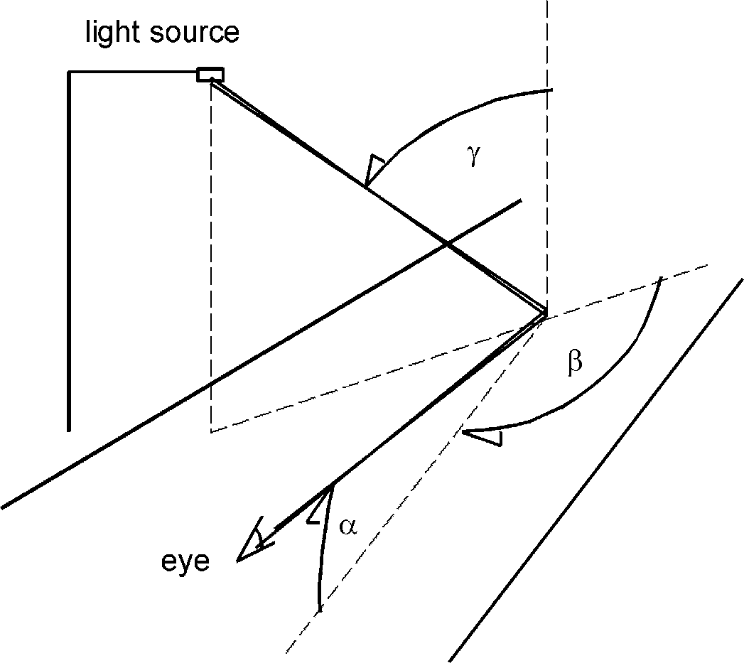
Fig. 2.1 Angles used to describe the geometry of illumination and observation in road lighting and daylight:
γ
β
α
Copyrighted material licensed to Toni Bonàs on 2026-05-06 for licensee's use only.
No further reproduction or networking is permitted. Distributed by Accuris, https://accuristech.com.
α: angle of observation measured between the direction of observation and the horizontal plane;
β: azimuth angle measured between the two vertical planes containing the directions of illumination and observation;
γ: angle of incidence measured from the vertical to the direction of illumination.

Note: A full description of the geometry requires an additional, fourth angle δ, measured as a rotation of the direction of observation around the vertical, bringing this direction away from the direction of the road. This angle, however, is considered as not influencing the value of the luminance coefficient and is normally set to 0° during measurement.

Influence of measurement angles
The angle γ varies in the range from 0° up close to 90°, while β is relevant from -180° to 180°. Generally q is considered to be independent of the sign of β, its interesting range therefore is from 0° to 180°.
All surfaces show a feature called specular reflection, which is caused by mirror reflection in the glossy surfaces of facets in the texture. This type of reflection provides large q values in a small angular range. It is indicated by a strong increase in the value of q, when γ increases and β is close to 0°. Some explanation is given in Fig. 2.2.
In the remaining part of the angular range, a diffuse type of reflection from the texture dominates, leading to roughly constant q values. However, there is a gradual increase in q, when γ increases and β is about 180°. The reason is simply that the illumination direction gets closer to the observation direction, so that those facets in the texture that are unobstructed for the observer are simultaneously unobstructed for illumination.
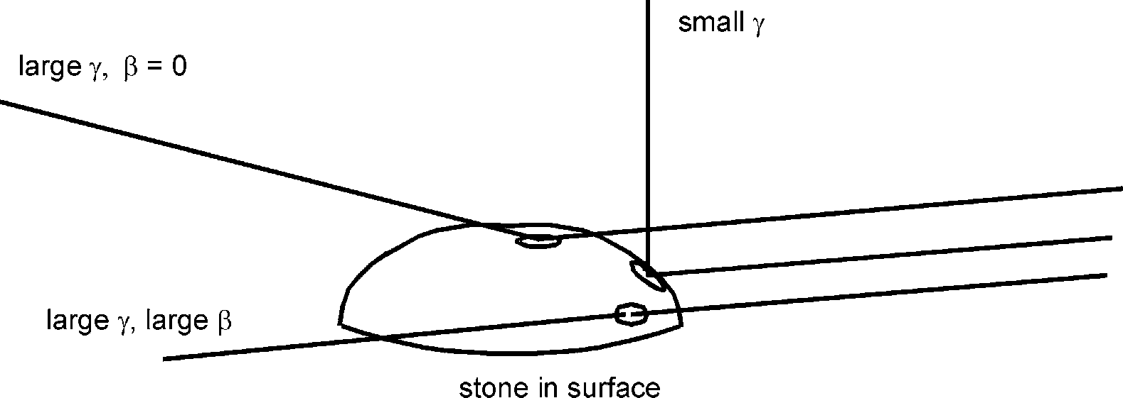
γ
γ, β
γ,
β
Fig. 2.2 Specular reflection is strong when the angle of incidence γ is large and the azimuth angle β is about 0° because:
    - reflection occurs through a small angle, where the reflectance of glossy surfaces is large;
    - reflection occurs on the top of stones, where a relatively large area is available.

This is related to retroreflection and is not as strong as specular reflection in the geometrical conditions of interest in road lighting or daylight. For headlamp illumination it is a significant feature. See section 3.2.
Copyrighted material licensed to Toni Bonàs on 2026-05-06 for licensee's use only.
No further reproduction or networking is permitted. Distributed by Accuris, https://accuristech.com.
For car driving the observation angle α in the range from 0,5° to 2° is of interest. In this range, the value of q does not change significantly with α according to de Boer, Onate and Oostrijk (1952). Measurements have traditionally been done at α = 1°.
It is necessary to consider the q values in an extended range of α to allow the calculation of road surface luminance at larger α values for various purposes, such as the visualization of road scenes. Extension to the full range from 0° to 90° would allow calculation of reflected illumination of for instance objects in tunnel lighting.

Reflection tables
Reflection tables provide q values for certain angle ranges.
Usually, the observation angle α is fixed at 1° so that the tabulation is for ranges of the angles β and γ. Table 2.1 shows the standard format, which is adopted by most computer programs for the design of road lighting installations.
The standard format contains values of the reduced luminance coefficient r defined as q·cos³γ. For convenience, values in the table have been multiplied by 10 000. Steps are arranged according to tanγ instead of γ directly.
Tables in the standard format providing r values are often called r-tables. For storing in files and transfer electronically, the standard file format shown in Table 2.2 is used.
Table 2.1 Standard format for r-tables. Values are r = q·cos³γ multiplied by 10 000.

 | β (°)
tgγ | 0 | 2 | 5 | 10 | 15 | 20 | 25 | 30 | 35 | 40 | 45 | 60 | 75 | 90 | 105 | 120 | 135 | 150 | 165 | 180
0 | 474 | 474 | 474 | 474 | 474 | 474 | 474 | 474 | 474 | 474 | 474 | 474 | 474 | 474 | 474 | 474 | 474 | 474 | 474 | 474
0.25 | 472 | 471 | 471 | 470 | 470 | 468 | 466 | 464 | 463 | 459 | 456 | 450 | 443 | 439 | 435 | 434 | 434 | 435 | 436 | 436
0.5 | 427 | 426 | 426 | 423 | 418 | 413 | 408 | 399 | 390 | 382 | 375 | 359 | 347 | 343 | 341 | 344 | 348 | 352 | 353 | 356
0.75 | 374 | 372 | 370 | 361 | 349 | 336 | 322 | 309 | 297 | 285 | 275 | 255 | 245 | 244 | 245 | 253 | 256 | 262 | 265 | 268
1 | 326 | 323 | 319 | 303 | 284 | 263 | 243 | 227 | 213 | 202 | 193 | 177 | 170 | 170 | 174 | 180 | 186 | 192 | 196 | 199
1.25 | 284 | 281 | 275 | 251 | 224 | 198 | 176 | 161 | 149 | 139 | 132 | 121 | 117 | 119 | 123 | 129 | 135 | 141 | 145 | 147
1.5 | 249 | 246 | 235 | 203 | 172 | 146 | 127 | 113 | 104 | 97 | 92 | 84 | 83 | 85 | 89 | 94 | 99 | 105 | 108 | 110
1.75 | 219 | 216 | 201 | 162 | 129 | 106 | 91 | 81 | 73 | 68 | 64 | 60 | 59 | 62 | 65 | 70 | 74 | 79 | 82 | 84
2 | 194 | 190 | 171 | 129 | 97 | 78 | 65 | 57 | 53 | 49 | 46 | 44 | 44 | 46 | 49 | 53 | 57 | 61 | 64 | 65
2.5 | 157 | 150 | 124 | 82 | 57 | 44 | 37 | 32 | 30 | 28 | 27 | 26 | 26 | 28 | 30 | 33 | 37 | 40 | 42 | 43
3 | 130 | 120 | 90 | 52 | 35 | 26 | 22 | 19 | 18 | 17 | 17 | 16 | 17 | 18 | 20 | 22 | 24 | 27 | 28 | 29
3.5 | 110 | 98 | 65 | 34 | 22 | 16 | 14 | 13 | 12 | 11 | 11 | 11 | 11 | 12 | 14 | 16 | 18 | 19 | 21 | 21
4 | 94 | 80 | 48 | 23 | 15 | 11 | 9 | 9 | 8 | 8 | 8 | 8 | 8 | 9 | 10 | 12 | 13 | 15 | 16 | 16
4.5 | 80 | 65 | 36 | 17 | 10 | 8 | 7 | 6 | 6 | 6 | 6 | 6 | 6 | 7 | 8 | 9 | 10 | 11 | 12 | 13
5 | 70 | 55 | 28 | 12 | 8 | 6 | 5 | 5 | 4 | 4 | 4 | 4 | 5 | 5 | 6 | 7 | 8 | 9 | 10 | 10
5.5 | 61 | 46 | 22 | 9 | 6 | 4 | 4 | 4 | 3 | 3
6 | 54 | 39 | 18 | 7 | 5 | 4 | 3 | 3 | 3
6.5 | 48 | 34 | 14 | 6 | 4 | 3 | 2 | 2
7 | 43 | 30 | 12 | 5 | 3 | 2 | 2 | 2
7.5 | 39 | 27 | 10 | 4 | 2 | 2 | 2
8 | 36 | 23 | 9 | 3 | 2 | 2 | 1
8.5 | 33 | 21 | 7 | 3 | 2 | 1 | 1
9 | 30 | 18 | 6 | 2 | 1 | 1
9.5 | 28 | 17 | 5 | 2 | 1 | 1
10 | 26 | 16 | 5 | 2 | 1 | 1
10.5 | 25 | 14 | 4 | 1 | 1 | 0
11 | 23 | 13 | 4 | 1 | 1 | 0
11.5 | 22 | 12 | 3 | 1 | 1
12 | 21 | 12 | 3 | 1 | 1

Table 2.2 Standard file format of r-tables.
Copyrighted material licensed to Toni Bonàs on 2026-05-06 for licensee's use only.
No further reproduction or networking is permitted. Distributed by Accuris, https://accuristech.com.

999,562 N2 (DRY), Q0(DRY)= 0,07, (FILE=N2C30)
29
474 | 472 | 427 | 374 | 326 | 284 | 249 | 219 | 194 | 157 | 130 | 110 | 94 | 80 | 70 | 61 | 54
48 | 43 | 39 | 36 | 33 | 30 | 28 | 26 | 25 | 23 | 22 | 21
29
474 | 471 | 426 | 372 | 323 | 281 | 246 | 216 | 190 | 150 | 120 | 98 | 80 | 65 | 55 | 46 | 39
34 | 30 | 27 | 23 | 21 | 18 | 17 | 16 | 14 | 13 | 12 | 12
.
.
.
15
474 | 435 | 352 | 262 | 192 | 141 | 105 | 79 | 61 | 40 | 27 | 19 | 15 | 11 | 9
15
474 | 436 | 353 | 265 | 196 | 145 | 108 | 82 | 64 | 42 | 28 | 21 | 16 | 12 | 10
15
474 | 436 | 356 | 268 | 199 | 147 | 110 | 84 | 65 | 43 | 29 | 21 | 16 | 13 | 10
Note: The file is a text file with:
- an initial line containing a reference identification number for the table and perhaps additional description of the table;
- maximum three lines for each column of the standard r-table format, where the first line contains the number of values in the column, the second line contains the first 17 values of the column and the third line contains the last 12 values of the column;
- values are integers using four characters per value.
The standard format of the r-table covers a certain field of the surface below a single light source, see Fig. 2.3. This field may be considered to extend a distance of 4·h from the light source onwards in the direction of travel (away from the observer), a distance of 12·h from the light source in the opposite direction (towards the observer) and ±3·h in the transverse direction, where h is the mounting height of the light source above the surface. The tables are intended primarily for design calculations of road lighting installations.
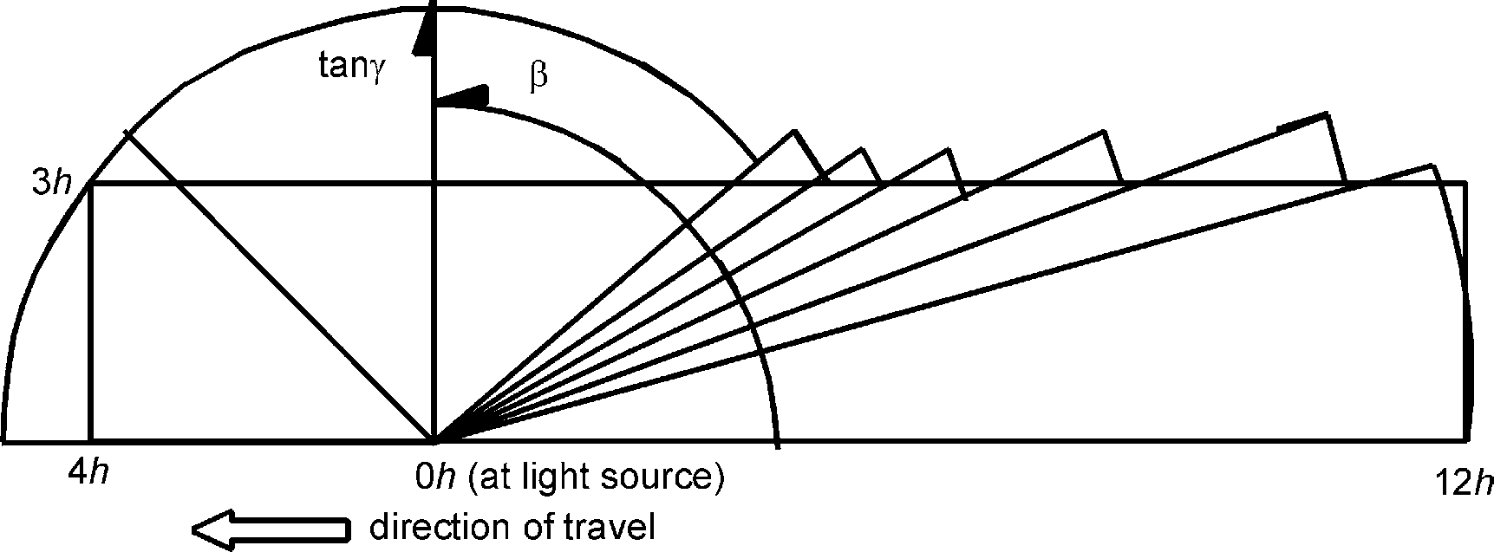
γ
β
Fig. 2.3 A: Coverage of the r-table seen from above. The format of the r-table defines a field confined by sections of circles, but for road lighting purposes the coverage is defined as a rectangular field which, except at a few corners, is enclosed within the above-mentioned field (see text).

Copyrighted material licensed to Toni Bonàs on 2026-05-06 for licensee's use only.
No further reproduction or networking is permitted. Distributed by Accuris, https://accuristech.com.
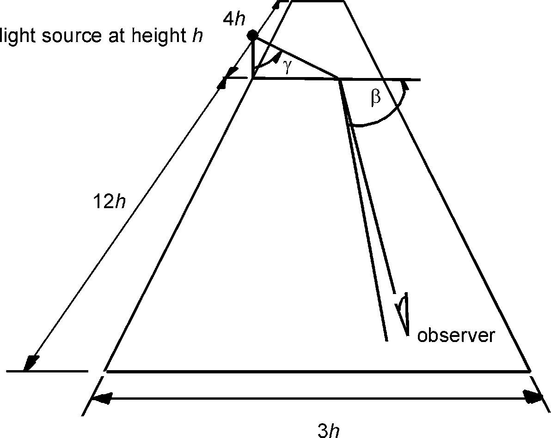
Fig. 2.3 B: Area seen in perspective.
β
The r-table in the standard format covers a certain field of the surface below a light source at a mounting height h.

Description system
Most surfaces can be reasonably well characterized by their lightness (or degree of whiteness or blackness) and their specularity (or shininess). The parameters adopted for the description system are:
- for lightness:
the luminance coefficient in diffuse illumination Qd (of a field of a surface), the quotient of the luminance of the field of the surface in the given direction by the illuminance on the field.
or
the average luminance coefficient Q0 (of a field of a surface), defined by:

Q0 = 1 q dω
∫
Ω Ω
where Ω is the solid angle defined by the rectangle of Fig. 2.3.
- for specularity:
the specular factor S1 (of a field of a surface), the quotient of r(tanγ =2, β =0°) by
r(tanγ =0, β =0°).
Note1: Another description system has been suggested by Burghout (1977), using a basic r value to characterize the lightness, and two other r values in proportion to the basic r value to characterize the shape of the reflection indicatrix. Vidal (1996) suggests a similar system using a total of four r values.
The two parameters for lightness are related in the sense that Qd as well as Q0 is an average luminance coefficient, although Qd is obtained with the weight of cosγ (Qd = ∫q·cosγ·dω /π where the integral is for the hemisphere above the road surface and π is introduced being equal to ∫cosγ dω). As cosγ decreases with increasing angle of incidence γ, if there is a strong specular reflection, it appears in Qd with less weight as in Q0.
Diffuse illumination is the illumination provided by a surrounding above the surface with a uniform luminance. Such an illumination can be established with relative ease, in particular within a photometric sphere or by the opening of a photometric sphere, see Annex A.

Qd can therefore be measured directly using integrating method by establishing diffuse illumination. In principle, Q0 can also be measured similarly, but this requires illumination from a surrounding, which is shaped as the rectangle of Fig. 2.3 and has a variation of luminance in inverse proportion to cosγ. In practice it is very difficult to establish such an illumination and the method is not used.
Copyrighted material licensed to Toni Bonàs on 2026-05-06 for licensee's use only.
No further reproduction or networking is permitted. Distributed by Accuris, https://accuristech.com.
Note2: Qd is a ”new” parameter, introduced in EN 1436:1997, ”Road marking materials - Performance for road users” in order to represent the lightness of road markings in daylight conditions. Qd is applicable to road surfaces, too, as it is explained in the following and has the advantage that it can be measured in situ.
Q0 is the ”old” parameter of conventional use for road surfaces in road lighting; refer to CIE 30.2-1982 (replaced by CIE 140 – 2001) and CIE 66-1984. In spite of several attempts, methods for reliable in situ measurement have not been developed.
Q0 must be obtained by numerical integration of values of an r-table. The following expression applies:
Q0 = ∑(q ⋅ ∆ω )/ ∑(∆ω )
where summations are for values of the reflection table and Δω is the solid angle attributed to each value
This expression is the basis for a procedure derived by Sørensen (1974) and is given in Table 2.3. Qd can be obtained in a slightly modified procedure, which is based on the following expression and is also given in Table 2.3:
Qd = ∑(q ⋅ cosγ ⋅ ∆ω )/ ∑(cosγ ⋅ ∆ω)
Table 2.3 Weighting factors for the calculation of Qd or Q0 from r-tables.

 | β (°)
tgγ | 0 | 2 | 5 | 10 | 15 | 20 | 25 | 30 | 35 | 40 | 45 | 60 | 75 | 90 | 105 | 120 | 135 | 150 | 165 | 180
0 | 8 | 8 | 32 | 22 | 40 | 20 | 40 | 20 | 40 | 25 | 45 | 120 | 60 | 120 | 60 | 120 | 60 | 120 | 60 | 60
0,25 | 32 | 32 | 128 | 88 | 160 | 80 | 160 | 80 | 160 | 100 | 180 | 480 | 240 | 480 | 240 | 480 | 240 | 480 | 240 | 240
0,5 | 16 | 16 | 64 | 44 | 80 | 40 | 80 | 40 | 80 | 50 | 90 | 240 | 120 | 240 | 120 | 240 | 120 | 240 | 120 | 120
0,75 | 32 | 32 | 128 | 88 | 160 | 80 | 160 | 80 | 160 | 100 | 180 | 480 | 240 | 480 | 240 | 480 | 240 | 480 | 240 | 240
1 | 16 | 16 | 64 | 44 | 80 | 40 | 80 | 40 | 80 | 50 | 90 | 240 | 120 | 240 | 120 | 240 | 120 | 240 | 120 | 120
1,25 | 32 | 32 | 128 | 88 | 160 | 80 | 160 | 80 | 160 | 100 | 180 | 480 | 240 | 480 | 240 | 480 | 240 | 480 | 240 | 240
1,5 | 16 | 16 | 64 | 44 | 80 | 40 | 80 | 40 | 80 | 50 | 90 | 240 | 120 | 240 | 120 | 240 | 120 | 240 | 120 | 120
1,75 | 32 | 32 | 128 | 88 | 160 | 80 | 160 | 80 | 160 | 100 | 180 | 480 | 240 | 480 | 240 | 480 | 240 | 480 | 240 | 240
2 | 24 | 24 | 96 | 66 | 120 | 60 | 120 | 60 | 120 | 75 | 135 | 360 | 180 | 360 | 180 | 360 | 180 | 360 | 180 | 180
2,5 | 64 | 64 | 256 | 176 | 320 | 160 | 320 | 160 | 320 | 200 | 360 | 960 | 480 | 960 | 480 | 960 | 480 | 960 | 480 | 480
3 | 32 | 32 | 128 | 88 | 160 | 80 | 160 | 80 | 160 | 100 | 180 | 480 | 240 | 480 | 240 | 480 | 240 | 480 | 240 | 240
3,5 | 64 | 64 | 256 | 176 | 320 | 160 | 320 | 160 | 320 | 200 | 120 | 270 | 33 | 0 | -30 | 690 | 480 | 960 | 480 | 480
4 | 32 | 32 | 128 | 88 | 160 | 80 | 160 | 80 | 160 | 100 | 60 | 0 | 0 | 0 | -75 | -30 | 255 | 510 | 222 | 120
4,5 | 64 | 64 | 256 | 176 | 320 | 160 | 320 | 160 | 320 | 155 | 75 | 0 | 0 | 0 | 0 | 0 | 135 | 372 | 33 | 0
5 | 32 | 32 | 128 | 88 | 160 | 80 | 160 | 105 | 125 | 5 | -15 | 0 | 0 | 0 | 0 | 0 | 0 | 33 | 0 | 0
5,5 | 64 | 64 | 256 | 176 | 320 | 160 | 320 | 170 | 90 | 0 | 0 | 0 | 0 | 0 | 0 | 0 | 0 | 0 | 0 | 0
6 | 32 | 32 | 128 | 88 | 160 | 80 | 160 | 40 | 0 | 0 | 0 | 0 | 0 | 0 | 0 | 0 | 0 | 0 | 0 | 0
6,5 | 64 | 64 | 256 | 176 | 320 | 160 | 275 | 35 | 0 | 0 | 0 | 0 | 0 | 0 | 0 | 0 | 0 | 0 | 0 | 0
7 | 32 | 32 | 128 | 88 | 160 | 105 | 80 | -25 | 0 | 0 | 0 | 0 | 0 | 0 | 0 | 0 | 0 | 0 | 0 | 0
7,5 | 64 | 64 | 256 | 176 | 320 | 170 | 90 | 0 | 0 | 0 | 0 | 0 | 0 | 0 | 0 | 0 | 0 | 0 | 0 | 0
8 | 32 | 32 | 128 | 88 | 160 | 85 | 45 | 0 | 0 | 0 | 0 | 0 | 0 | 0 | 0 | 0 | 0 | 0 | 0 | 0
8,5 | 64 | 64 | 256 | 176 | 320 | 80 | 0 | 0 | 0 | 0 | 0 | 0 | 0 | 0 | 0 | 0 | 0 | 0 | 0 | 0
9 | 32 | 32 | 128 | 88 | 160 | 40 | 0 | 0 | 0 | 0 | 0 | 0 | 0 | 0 | 0 | 0 | 0 | 0 | 0 | 0
9,5 | 64 | 64 | 256 | 176 | 320 | 80 | 0 | 0 | 0 | 0 | 0 | 0 | 0 | 0 | 0 | 0 | 0 | 0 | 0 | 0
10 | 32 | 32 | 128 | 88 | 115 | -5 | 0 | 0 | 0 | 0 | 0 | 0 | 0 | 0 | 0 | 0 | 0 | 0 | 0 | 0
10,5 | 64 | 64 | 256 | 176 | 230 | -10 | 0 | 0 | 0 | 0 | 0 | 0 | 0 | 0 | 0 | 0 | 0 | 0 | 0 | 0
11 | 32 | 32 | 128 | 113 | 80 | -25 | 0 | 0 | 0 | 0 | 0 | 0 | 0 | 0 | 0 | 0 | 0 | 0 | 0 | 0
11,5 | 64 | 64 | 256 | 186 | 90 | 0 | 0 | 0 | 0 | 0 | 0 | 0 | 0 | 0 | 0 | 0 | 0 | 0 | 0 | 0
12 | 16 | 16 | 64 | 69 | 45 | 0 | 0 | 0 | 0 | 0 | 0 | 0 | 0 | 0 | 0 | 0 | 0 | 0 | 0 | 0
Note3: Each r value of the table is multiplied by the corresponding weighting factor and by a geometrical factor. The resulting values are summed and the result is scaled to derive the Qd or Q0 values.

The geometrical factor is sinγ for Qd and tanγ for Q0. The scaling is by division with 6,097·10⁷ for Qd and 9,936·10⁷ for Q0.
Copyrighted material licensed to Toni Bonàs on 2026-05-06 for licensee's use only.
No further reproduction or networking is permitted. Distributed by Accuris, https://accuristech.com.
The weighting factors are based on Simpson's method of integration and on assuming quadratic interpolation within the boundaries indicated in Fig. 2.3. They incorporate corrections for the discontinuities in the β and tanγ increments of the reflection table.
For Qd, the procedure of Table 2.3 involves the approximation that not the entire upper hemisphere is included in the summations. However, the value of E summed up from the reflection table is 94% of the value that would result from a summation for the whole upper hemisphere. This implies that Qd values derived from reflection tables are in good agreement with Qd values derived by direct measurement.
Note4: In situ measurement of Qd is carried out at an observation angle of 2,29° according to EN 1436:1997. When derived from an r-table, Qd corresponds to the observation angle used in the measurement of that r-table, normally 1°. However, Qd is not sensitive to the observation angle in this range.
Q0 is in practice derived from r-tables. The simultaneous use of Qd, Q0 and r-tables implies interchangeable use of 2,29° and 1° for the observation angle. This does not result in significant discrepancies, but a single value should be selected eventually.
The specular factor S1 can be obtained by the measurement of the two r values of the defining quotient. These are both included among the values of the r-table of the standard format.

Classification
A classification system groups different surfaces according to the value of the specular factor S1. Surfaces within a class are represented by a standard r-table typical of that particular class.
For dry weather conditions, three different classifications are in use in different countries, see Table 2.4. A classification for wet weather conditions is used in some countries, see Table 2.5.
Note1: CIE 66-1984 introduces the C classification as the standard classification system to be used for the design of road lighting installations. It is valuable for harmonisation that a standard classification system is available for this purpose. The C classification should be used whenever possible. Attempts should be made to find a long term solution.
Note2: In CIE 47-1971 a corrected specular factor S1' was used for the W classification.
Note3: The classifications are based on the road surface sampling of the 60's and 70's and may not be applicable to the latest road surface types.
The tables of the various classifications are given in Annex B.
Table 2.4 C, R and N classifications for dry road surfaces.

Class |  | Table
Name | S1 range | Name | S1 | Qd | Q0 | Q0/Qd
CI  CII | S1<0,40  0,40≤S1 | C1  C2 | 0,24  0,97 | 0,090  0,054 | 0,100  0,070 | 1,11  1,30
RI RII RIII RIV | S1<0,42 0,42≤S1<0,85  0,85≤S1<1,35  1,35≤S1 | R1 R2 R3 R4 | 0,25  0,58  1,11  1,55 | 0,087  0,057  0,050  0,052 | 0,100  0,070  0,070  0,080 | 1,15  1,23  1,40  1,54
NI NII NIII NIV | S1<0,28 0,28≤S1<0,60  0,60≤S1<1,30  1,30≤S1 | N1 N2 N3 N4 | 0,18  0,41  0,88  1,61 | 0,092  0,061  0,054  0,054 | 0,100  0,070  0,070  0,080 | 1,09  1,15  1,30  1,48

Table 2.5 W classification for wet road surfaces.
Copyrighted material licensed to Toni Bonàs on 2026-05-06 for licensee's use only.
No further reproduction or networking is permitted. Distributed by Accuris, https://accuristech.com.

Class |  | Table
Name | S1 range | Name | S1 | Qd | Q0 | Qd/Q0
WI WII WIII WIV | S1< 4,5  4,5≤S1< 7,2  7,2≤S1< 9,8  9,8≤S1<12^{*)} | W1 W2 W3 W4 | 3,2  5,7  8,7  10,9 | 0,080  0,092  0,107  0,116 | 0,114  0,150  0,196  0,247 | 1,43  1,63  1,83  2,13
^{*)} for S1≥12 no class applies

Luminance of surfaces in road lighting
Some important criteria for the design of road lighting for traffic routes are based on the luminance of the road surface. The criteria for the dry condition are the average road surface luminance, the overall uniformity and in some cases the longitudinal uniformity. Some countries apply an additional criterion for a wet condition for the overall uniformity; see CIE 115-1995.
This requires an r-table to be available to represent the road surface in design calculations. The basis for the calculations is that the luminance of a field can be expressed by:
L = Σ(I/h²) r
where I is the luminous intensity of a light source towards the field;
h is the mounting height of the light source;
r is the r value for the particular geometrical situation.
The r-table can be obtained in the following ways:
- The r-table is measured for the road surface.
- Qd and S1 are measured for the road surface, an r-table of about the same S1 value is selected and rescaled to the same Qd value.
- A standard r-table is selected from one of the classifications according to the type of road surface.
Re a):
Measurement of the full r-table can be carried out in the laboratory only, this requires
that a sample be taken from the road surface.
In the design stage of road lighting, the road surface may not yet have been laid, or it may not yet represent the surface in a worn state. Furthermore, a road surface does change somewhat during its functional life. Sometimes the road is even resurfaced.
Therefore, it is not practical to base the design of a lighting installation on an r-table measured for the individual road surface at some point in time. Normally, a standard r-table is used.
In practice, measurements of r-tables are used for research purposes to reveal typical reflection properties of commonly used road surfaces and to investigate properties of new types of road surfaces.
Re b):
An intention of the description system is that its parameters can be measured in situ on a road surface. An r-table, which is selected according to the S1 value and rescaled according to the Qd value, represents the road surface with a suitable accuracy.
For the reasons stated above, it is not practical to base the design of a lighting installation on that particular r-table. The purpose of in situ measurement is mainly to verify assumptions regarding a certain standard r-table.

In principle, Q0 can be measured instead of Qd as the two parameters serve the same purpose as of rescaling a selected r-table. However, Q0 is less suitable for in situ measurement and no equipment is available for this purpose.
Copyrighted material licensed to Toni Bonàs on 2026-05-06 for licensee's use only.
No further reproduction or networking is permitted. Distributed by Accuris, https://accuristech.com.
For the time being, no equipment is available for the measurement of S1 either. Therefore, the r-table has to be selected from one of the classifications according to the type of road surface and to be rescaled according to the measured Qd value.
The uncertainty of this procedure lies in the choice of standard r-table, which may not reflect the S1 of the actual road surface. This uncertainty effects primarily the uniformities of road surface luminance in road lighting, but it involves an additional uncertainty for the average road surface luminance, too.
The uncertainty regarding uniformities can be tested in practical cases by repeated design calculations for standard r-tables of different S1. If S1 is higher than assumed, the overall uniformity is often lower and the longitudinal uniformity is often higher.
The uncertainty regarding average luminance can be tested the same way. The result depends on an aspect of the directionality of illumination, which in broad terms may be called "degree of specular illumination".

The average road surface luminance L can be expressed as L = Q· E where Q is an

average luminance coefficient of the road surface and E is the average illuminance on the road surface.
When the degree of specular illumination is low, the value of Q is close to Qd irrespective of the S1 value. Accordingly, the uncertainty of the average road surface luminance is small.
When the degree of specular illumination is high, on the other hand, Q approaches or even exceeds Q0. As the Q0 value exceeds the Qd value by an amount that depends on the S1 value, the uncertainty of the average road surface luminance is not necessarily small. The uncertainty can be estimated by means of the ratio Q0/Qd, which is given in Tables 2.3 and
2.4 and also shown in Fig. 2.4.
Road lighting with a high degree of specular illumination is typical in most countries because of the resulting gain in average road surface luminance. Road lighting with a low degree of specular illumination is typical in countries that apply the above-mentioned additional criterion for the wet condition. The main difference is the use of light distribution of small versus large toe-in angles.

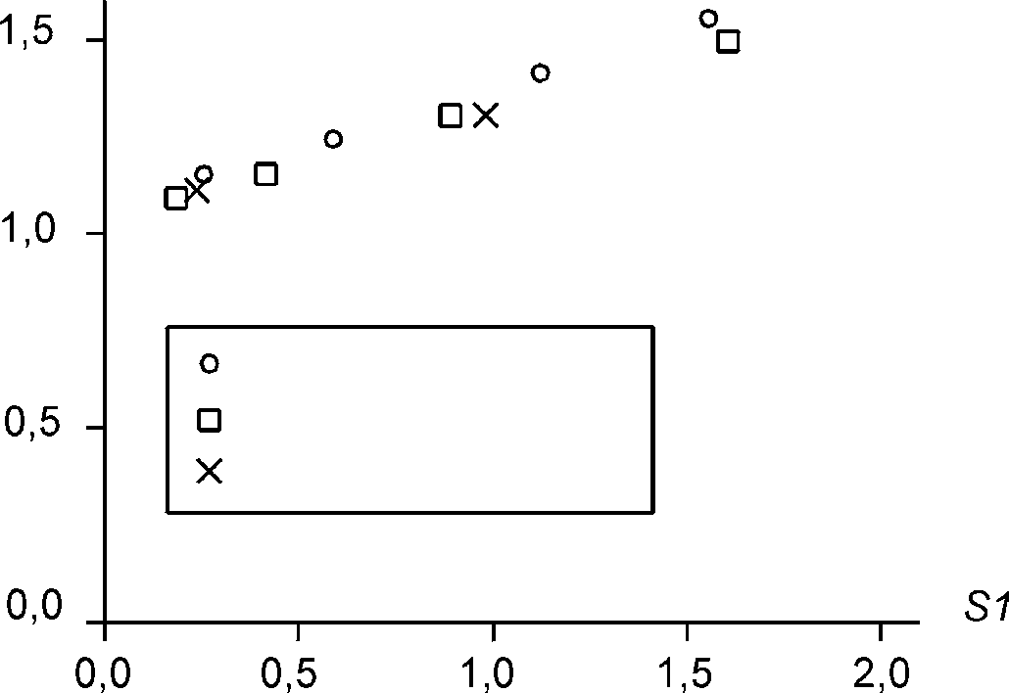
Fig. 2.4
Q0/Qd
R1, R2, R3 and R4 N1, N2, N3 and N4
C1 and C2
S1
Q0/Qd ratios of standard r-tables.

Re c):
In practice a standard r-table is selected from one of the classifications according to
the type of road surface.
Guidance is often given in national standards for road lighting, stating for instance that a particular standard r-table is to be used for asphalt road surfaces and another for cement concrete surfaces.

A single r-table is often used for broad categories of roads allowing luminaire suppliers to supply luminaire documentation in the form of design tables and leaving little room for doubt and mistakes regarding the assumptions for the road surface.
Copyrighted material licensed to Toni Bonàs on 2026-05-06 for licensee's use only.
No further reproduction or networking is permitted. Distributed by Accuris, https://accuristech.com.
The disadvantage is of course that there is little incentive to test the actual properties of the road surface. Cases can be found where the actual road surface luminance is only half of the designed value.

Luminance of surfaces in daylight
The sun provides a surface luminance of L = E·q, where E is the illuminance by the sun on a horizontal plane and q is the luminance coefficient.
The illuminance by the sun depends on the height of the sun above the horizon. It is typically 100 000 lx or more, when the sun is near the zenith and decreases with decreasing sun height because of the cosine law of illumination and because of increased absorption and scattering in the atmosphere. Data can be found in the literature, e.g. Krochmann et al. (1970).
The luminance coefficient q depends on the road surface, on the height of the sun and its location with respect to the viewing direction. A particular feature is that q is high, when the sun is low and opposes the viewing direction.
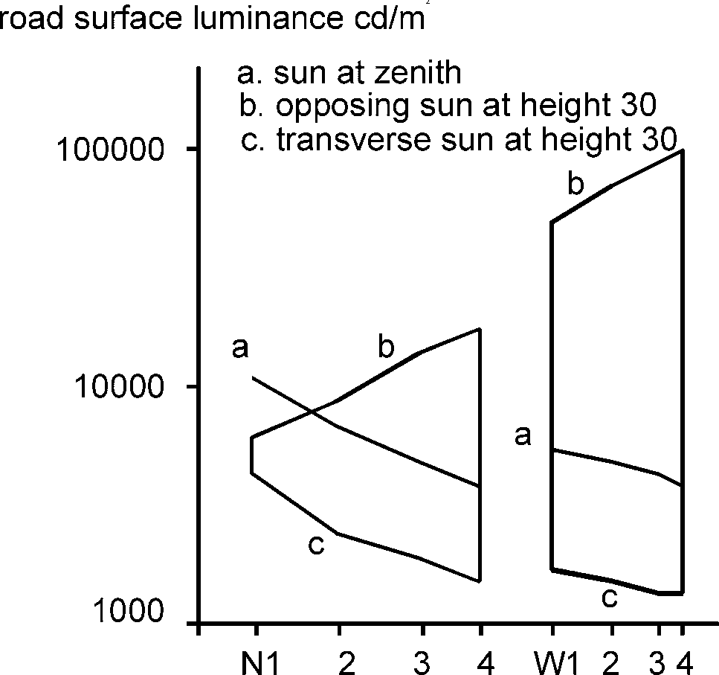
Examples of road surface luminance in sunlight are given in Fig. 2.5.
2
°
°
logS1
N1 N2 N3 N4 W1 W2 W3 W4
Fig. 2.5 Road surface luminance at illumination by the sun. The
illuminance for the sun at zenith
and a sun height of 30° is assumed to be respectively 130 000 lx and 44 000 lx.
Results are shown for road reflection properties corresponding to N1, N2, N3 or N4 for the dry condition and W1, W2, W3 or W4 for the wet condition marked at log(S1) positions.

The sky provides a surface luminance of L = ∫L_{sky}·cosγ·q dω, where L_{sky} is the luminance of the sky at a certain location, γ is the angular distance of that location measured from the zenith, q is the luminance coefficient and ∫dω means integration for the upper hemisphere. In calculations, the integration has to be replaced by a summation using an r-table to provide q values for the surface.
Some special cases are the clear sky and the overcast sky. Only the overcast sky is considered in the following.
For the overcast sky, a typical distribution of luminance is given in CIE 16-1970 by L_{sky} =L_{zenith}· (1+2cosγ )/3, where L_{zenith} is the luminance of the sky at the zenith and γ is the angular distance of the location from the zenith to a location of the sky where the luminance is L_{sky}. This distribution is of rotational symmetry implying that the location of the sun is completely hidden. The sun height, however, determines the level of the luminance and the illuminance on the ground.

The illuminance is typically about 20 000 lx, when the sun is not too far from the zenith, and decreases with decreasing sun height to become a few hundred lux at dawn or dusk. Data can be found in the literature, e.g. Krochmann (1963).
Copyrighted material licensed to Toni Bonàs on 2026-05-06 for licensee's use only.
No further reproduction or networking is permitted. Distributed by Accuris, https://accuristech.com.
The surface luminance is to some approximation given by the product of the Qd value and the illuminance by the overcast sky E, i.e. by Qd·E. The actual deviation is shown in Fig. 2.6 and for the standard r-tables the deviations are given in Table 2.6.

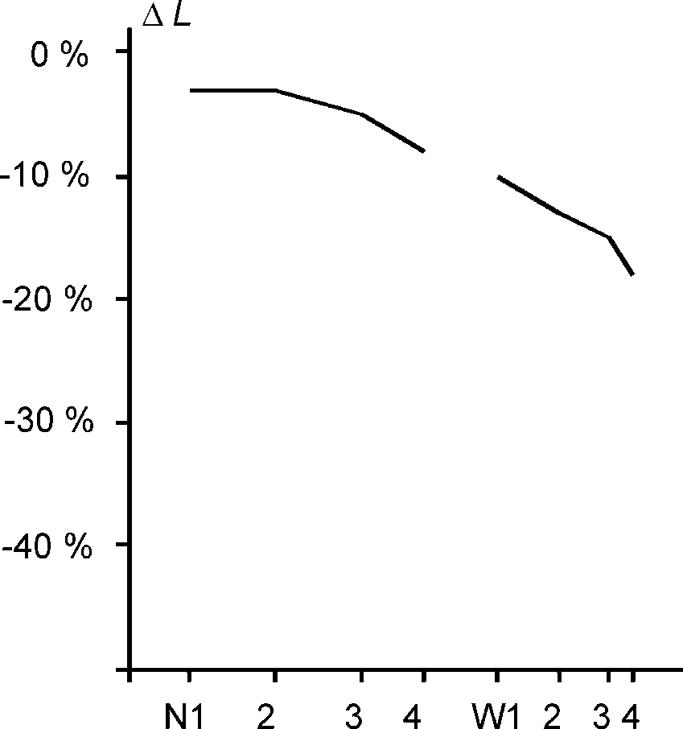
Fig. 2.6 Percentage deviation of the actual road surface luminance ΔL from the value estimated as the product of Qd and the illuminance from the CIE overcast sky.

logS1 N1 N2 N3 N4 W1 W2 W3 W4
Results are for road reflection properties corresponding to N1, N2, N3 or N4 for the dry condition and W1, W2, W3 or W4 for the wet condition marked at log(S1) positions.

Table 2.6 Percentage deviation of the actual road surface luminance ΔL from the value estimated as the product of Qd and the illuminance from the CIE overcast sky.

Table | C1 C2 R1 R2 R3 R4 N1 N2 N3 N4 W1 W2 W3 W4
ΔL(%) | -3 -6 -4 -5 -7 -9 -3 -3 -5 -8 -10 -13 -15 -18

VEHICLE HEADLAMP ILLUMINATION

Conventions
The coefficient of retroreflected luminance R_{L} of a field of a surface is the quotient of the luminance L of the field in the given direction by the illuminance E ⊥ at the field measured on a plane perpendicular to the direction of illumination. The unit is cd·m⁻²·lx⁻¹, but mostly the 1000 times smaller unit of mcd·m⁻²·lx⁻¹ is used.
The coefficient of retroreflected luminance R_{L} depends on the surface and the geometry of illumination and observation as described by the three angles shown in Fig. 3.1.
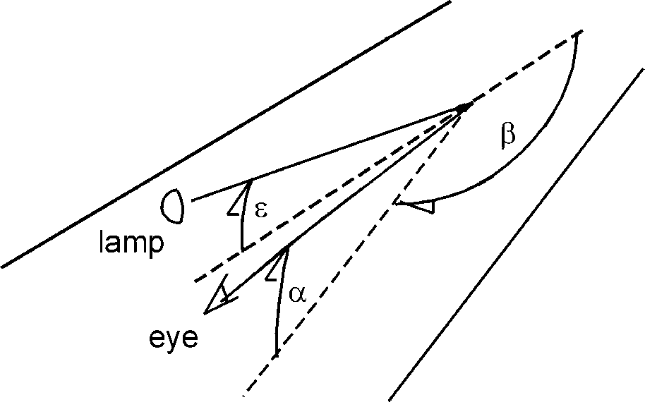
Fig. 3.1 Angles used to describe the geometry of illumination and observation in headlamp illumination:
β
ε
α
α: angle of observation measured from the direction of light incidence to the horizontal plane;
β: azimuth angle measured between the two vertical halfplanes containing the directions of illumination and observation;
ε: angle of incidence measured from the horizontal to the direction of illumination.

Note1: The angles α and β are the same as used for road lighting and daylight. The angle ε
Copyrighted material licensed to Toni Bonàs on 2026-05-06 for licensee's use only.
No further reproduction or networking is permitted. Distributed by Accuris, https://accuristech.com.
is 90°-γ, where γ is the angle of incidence used for road lighting and daylight.
Note2: A full description of the geometry requires an additional, fourth angle δ, measured as a rotation of the direction of observation around the vertical, bringing this direction away from the direction of the road. This angle, however, is considered not to influence the value of the luminance coefficient and is normally set to 0° during measurement.
Note3: CIE 73-1988 provides the above-mentioned coordinate system, originating from road lighting, and a coordinate system originating from retroreflectors as well.
Note4: CIE 54.2-2001 refers to the angles α, β, ε and δ by A, B, C and D.

Influence of measurement angles - surfaces in the drivers’ own headlamps
For vehicles with two headlamps, the total luminance is the sum of the luminances induced by each headlamp separately and expressed by L = R_{L}·E⊥. As the geometrical situations are different for the two headlamps, the R_{L} values are not identical.
In many cases this complexity is ignored by considering a simple vehicle with only one headlamp and with the eye position of the observer just above the headlamp.
The geometry is then described by the headlamp mounting height, the eye height of the observer and the distance to the point on the surface as measured along the surface. Assuming reasonably long distances, the angles ε and α form to a good approximation the same fixed ratio as the headlamp mounting height and the eye height of the observer. The angle β is 180°.
For a passenger car, the eye height is typically 1,2 m and the headlamp mounting height is about 0,65 m. Assuming that distances of 10 m to 100 m are relevant, the value of α is in the range of about 0,7° to 7° and the ratio of ε /α is 0,54.
For these conditions, the R_{L} for surfaces of relatively high R_{L} value does not change very much with the distance (i.e. with α ), and hardly in a systematic manner. This is confirmed by measurement data for road surfaces in Night Traffic report 4 (1982) and for road markings without glass beads in Night Traffic report 6 (1983). The R_{L}, on the other hand, varies in proportion to the ratio of ε /α.
The above-mentioned reports suggest an explanation.
Assume first that surfaces are truly plane and reflect in a diffuse manner according to a reflectance ρ. The R_{L} (in cd·m⁻²·lx⁻¹) of such surfaces is ρ·sinε/π ≈ ρ·ε/π (ε in radians), implying very small values and a variation with ε.
Note1: Consider a field of area A = 1 m² is illuminated by an illuminance E⊥ =1 lx. The projected area towards the illumination direction is A·sinε = sinε ≈ ε meaning that the illuminance on the plane of the field in lx is E = E⊥·ε = ε. The field reflects in a diffuse manner according to a reflectance ρ causing a luminance of L = ρ·E/π which is numerically equal to ρ·ε/π.
When ρ = 0,25 (for a medium light material) and ε = 0,65/30 = 0,0217 (for a headlamp mounting height of 0,65 m and a distance of 30 m) then R_{L} = 0,25·0,0217/π = 0,002 cd·m⁻²·lx⁻¹ = 2 mcd·m⁻²·lx⁻¹.
Very small R_{L} values are indeed measured for surfaces flooded by rain, hiding the texture, or for surfaces without texture like white opal plastic plates. The R_{L} is even lower than estimated, virtually naught, due to specular reflection of the incoming light.
For surfaces with texture, a much better assumption is that a relatively large fraction of the incoming light falls on facets with a significant tilt, facing towards the illumination direction. This is illustrated in Fig. 3.2.

Copyrighted material licensed to Toni Bonàs on 2026-05-06 for licensee's use only.
No further reproduction or networking is permitted. Distributed by Accuris, https://accuristech.com.
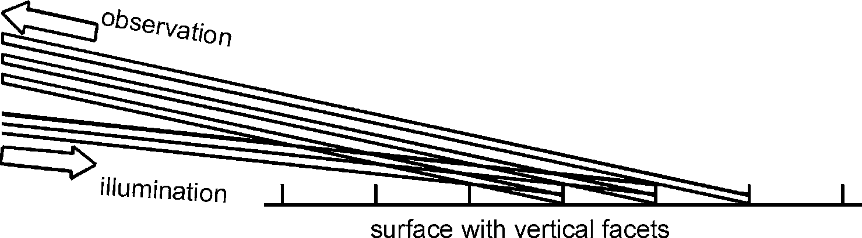
Fig. 3.2 Illumination and observation in a surface with vertical facets. The ratio of the angles of illumination and observation determine the fraction of the field of view occupied by illuminated facets.
The assumption leads to R_{L} = f·ρ·ε /(α·π) (ε in radians, unit of cd·m⁻²·lx⁻¹), where f can be understood as the above-mentioned fraction.
Note: A field of area A = 1 m² is illuminated by an illuminance E⊥ = 1 lx. The projected area towards the illumination direction is A·sinε = sinε ≈ ε meaning that the incoming luminous flux in lm is E⊥·ε = ε. Assume that a fraction f of the flux falls on facets facing the illumination and that these reflect the light according to a reflectance ρ. The reflected luminous intensity in cd is f·ρ·ε/π. The apparent area of the field is A·sinα = sinα ≈ α, the luminance L in cd·m⁻² is equal to f·ρ·ε/(α·π) and R_{L} in cd·m⁻²·lx⁻¹ is L/E⊥ = f·ρ·ε/(α·π).
When f = 0,5; ρ = 0,25 (for a medium light material) and ε/α = 0,65/1,2 = 0,54 (for a headlamp mounting height of 0,65 m and an observer eye height of 1,2 m), then R_{L} = 0,5·0,25·0,54/π = 0,021 cd·m⁻²·lx⁻¹ = 21 mcd·m⁻²·lx⁻¹.
When f and ρ do not change much with the angles, then R_{L} does not change much with the distance as seen from measurements. This seems to be the case for most surfaces, but of course there can be exceptions. An example is a profiled road marking, where all headlamp illumination falls on the profiles at long distances, but not at short distances.
The above-mentioned reports also include cases where β is not exactly 180°, because there is a transverse distance between the headlamp and the observer in the actual geometrical situation.
In normal cases, the R_{L} may be reduced by 10% to 15% for one or both of the headlamps of a passenger car. This is explained by the fact, that not all illuminated facets will be visible when not directly observed from the position above the headlamp.

Influence of measurement angles - road markings with glass beads in the drivers’ own headlamps
The R_{L} of road markings with active glass beads in the surface is considered in Night Traffic report 6 (1983). The R_{L} values are higher than for surface reflection, but generally not very high, and the R_{L} varies with the geometry on a very similar way.
This is not quite what would be expected, when comparing to lens based sheetings, where the reflection parameter R' has values of 100 cd·m⁻²·lx⁻¹ in some cases, strongly depending on the angular separation between observation and illumination directions.
The R_{L} of road markings is of a comparable parameter, but has much smaller values of typically 100 mcd·m⁻²·lx⁻¹ (a thousand times less) and only rarely exceeds 400 mcd·m⁻²·lx⁻¹. Further, the R_{L} value does not depend much on the angular separation between observation and illumination directions.
Note: R' is defined by CIE 54.2-2001. The angular separation between observation and illumination directions is called the observation angle α, but has obviously a definition that differs from the observation angle α of this report.
The above-mentioned Night Traffic report offers some explanation for this. Further information is offered by Vedam & Stoudt (1978).

Fig. 3.3 shows how a glass bead acts in a retroreflective manner together with the partly enclosing road marking material. The incoming light is focussed on the marking material behind the bead, where it is reflected into the glass bead to be collimated.
Copyrighted material licensed to Toni Bonàs on 2026-05-06 for licensee's use only.
No further reproduction or networking is permitted. Distributed by Accuris, https://accuristech.com.

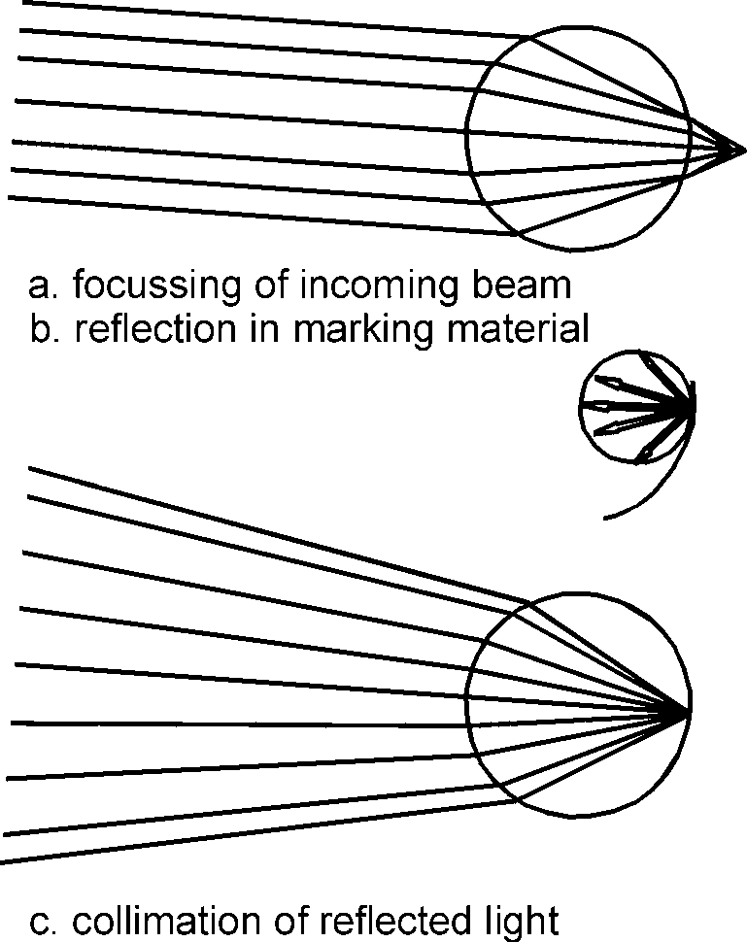
Fig. 3.3 A glass bead focusses the incoming light (a) on the marking material behind the bead, where it is reflected (b) into the glass bead to be collimated (c).

Fig. 3.3, however, also indicates that neither focussing nor collimation is perfect, causing the retroreflected beam to be rather wide. Accordingly, it is also of rather low intensity within the beam.
This partly explains why the R_{L} values are fairly low, and why they do not depend much on the angular separation between observation and illumination directions.
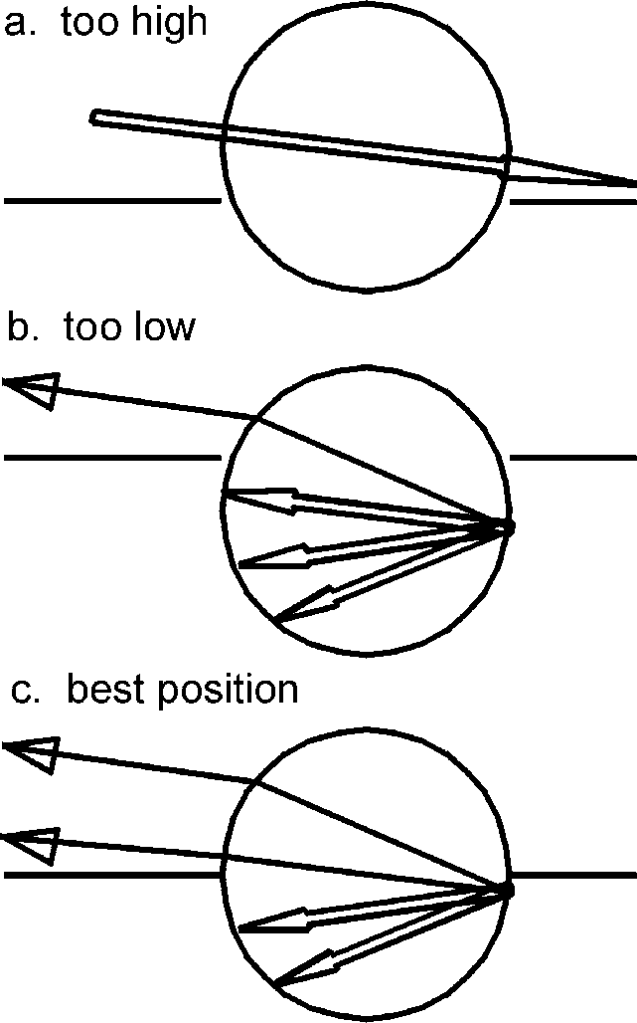
A further explanation for the rather low R_{L} values is given in Fig. 3.4. Some beads may be located too high in the surface, so that incoming light passes through, or too low, so that a large proportion of reflected light cannot leave. Only some beads are in the best location.

Fig. 3.4 When a bead is located too high in the surface, incoming light passes it (a). When located too low, a large proportion of reflected light cannot leave (b). The best position is indicated (c).

The result is that glass beads act in about the same way as tilted facets in the surface, however, greater individual variation of the R_{L} value exist.
Copyrighted material licensed to Toni Bonàs on 2026-05-06 for licensee's use only.
No further reproduction or networking is permitted. Distributed by Accuris, https://accuristech.com.
For some new road markings with a dense population of glass beads in the surface, the R_{L} value is often high at short distances, where all or most of the glass beads can be illuminated. At medium and long distances, the glass beads shadow each other and the R_{L} value is lower. For some worn road markings with few active glass beads in the surface, the variation is often the opposite, as the glass beads cannot fill the apparent area at short distances.

Influence of measurement angles - headlamps of other vehicles
Headlamps on vehicles going in the same direction as the driver, illuminate the road surface and road markings in geometry similar to the drivers own headlamps. The R_{L} can be described in the same way, meaning among others that it may have significant values.
Headlamps on vehicles going in the opposite direction cause specular reflection on some areas on the surface, where the azimuth angle β is close to 0°. This causes large values of R_{L} depending strongly on the measurement angles, particularly on β.
Note: The name of the "coefficient of retroreflected luminance" R_{L} implies that the parameter has primarily been introduced for use in connection with retroreflection as caused by the drivers own headlamps. However, the definition as a ratio between luminance and illuminance allows the use of this parameter in any context, including specular reflection.
The dependence on the azimuth angle is illustrated in Fig. 2.2. When β is 0°, specular reflection occurs at facets of a horizontal or near horizontal orientation. Such are frequent and cause strong reflection. When β is significantly different from 0°, specular reflection occurs at facets of a strong tilt, being much less frequent and causing only weak reflection.
A description of the facet model of specular reflection, in comparison to measurement data, is given by Lundkvist and Sørensen (1990).
The R_{L} for headlamps on vehicles going in a transverse direction, such as at road crossings, has not been studied. Values are probably very small.

IN SITU MEASUREMENT

Road lighting and daylight
There is the obvious need for in situ measurement of:
- The luminance coefficient in diffuse illumination Qd.
- The specular factor S1.
Qd characterizes the lightness of the surface as described in sections 2.6 and 2.7. It is suitable for the prediction of the average road surface luminance and indicates the typical luminance level of road markings.
Qd is incorporated in standards for road surfaces and road markings. As an example, EN 1436:1997 ”Road marking materials - Performance for road users” provides performance classes of Qd for road markings, the classification is based on their contrast to the road surface and their visibility in road lighting and daylight.
The above-mentioned EN specifies an observation angle α of 2,29° corresponding to a visual distance of 30 m, when observing from a height of 1,2 m above the road surface. The Qd value does probably not change much with increasing distance (decreasing α); see section 2.2. In this sense, the measurement geometry reflects the drivers need for visual distances of 30 m or more.
This Qd value is not difficult to measure in situ. Portable and vehicle mounted equipment is available on a commercial basis.

The value of 2,29° agrees with the one used for measuring the R_{L} of road markings according to the EN; see section 4.2. It disagrees, however, with the traditional use of an observation angle α of 1° for the measurement of r-tables, from which the Qd value can also be derived; see section 2.4. This matter is considered in section 4.3.
Copyrighted material licensed to Toni Bonàs on 2026-05-06 for licensee's use only.
No further reproduction or networking is permitted. Distributed by Accuris, https://accuristech.com.
S1 characterizes the specular properties of the surface as described in sections 2.6 and 2.7 and is suitable for the prediction of surface luminance in case of specular illumination.
A suitable measurement of the S1 value is relatively easy among laboratory conditions, but not in situ. Equipment for in situ measurement is not commercially available.

Vehicle headlamp illumination
EN 1436:1997 ”Road marking materials - Performance for road users” provides performance classes of R_{L} for road markings, the classification is based on their contrast to the road surface and their visibility in the illumination of the drivers own headlamps.
The EN further provides standard measurement geometry for the R_{L} specified by an observation angle α of 2,29° and an illumination angle ε of 1,24°. The azimuth angle β is 180°.
The same standard measurement geometry is specified in ASTM E 1710 "Standard test method for measurement of retroreflective pavement marking materials" (1995).
As it is mentioned in section 4.1, an observation angle α of 2,29° corresponds to a visual distance of 30 m when observing from a height of 1,2 m above the road surface. Similarly, an illumination angle ε of 1,24° corresponds to a distance of 30 m, when the headlamp is mounted at a height of 0,65 m.
The distance of 30 m is long enough to avoid most of those individual variations of the R_{L} mentioned in sections 3.2 and 3.3, so that the R_{L} at 30 m distance also applies for longer distances with some approximation; refer to Night Traffic reports 4 (1982) and 6 (1983). In this sense the measurement geometry reflects the drivers need for visual distances of 30 m or more.
This R_{L} value is not difficult to measure in situ. Portable and vehicle mounted equipment is commercially available.
The specular reflection of surfaces in the illumination provided by the headlamps of oncoming vehicles causes patches of high luminance on the road surface that are disturbing in themselves, sometimes it is even glaring and often obscures road markings.
It might be relevant to characterize this specular reflection by the coefficient of retroreflected luminance R_{L} in a suitable geometry. There is, however, no tradition for this and probably no standards relating to the matter. Equipment for in situ measurement is not commercially available.

Recommendations for in situ measurement of Qd and R_{L} for the drivers’ own headlamps
It is recommended that in situ measurement of Qd and R_{L} (drivers’ own headlamps) are carried out according to the specifications of Table 4.1, which agrees with EN 1436.
The relevance of an observation angle α of 2,29° is justified in sections 4.1 and 4.2.
Simultaneously, the relatively large angle allows suitable measurements.
The total angular spread of measurement directions is limited, and a minimum measurement field is specified in order to provide well defined measurements. Measurement methods are described in Annex A.
If the measurement field of a single measurement is not sufficient to characterize a surface, a larger total measured field can be obtained by repeated measurements. This, on the other hand, calls for a more tedious measurement procedure.
Most road surfaces and road markings are neutral of colour, but the correct measurement of for instance yellow road markings requires the luminance meter to be V(λ) corrected; see CIE 69-1987.

The illuminated field must cover the entire measurement field with a uniform illuminance and the same directionality on all positions. If not, measurements will have poor accuracy and repeatability.
Copyrighted material licensed to Toni Bonàs on 2026-05-06 for licensee's use only.
No further reproduction or networking is permitted. Distributed by Accuris, https://accuristech.com.

Table. 4.1 Specifications for in situ measurement of Qd and R_{L}.

Luminance measurement (Qd and R_{L})
observation angle α : 2,29°
total angular spread : maximum ±0,17° (±10') vertical
maximum ±0,17° (±10') horizontal ¹⁾
measurement area : minimum 50 cm² ²⁾
luminance meter : V(λ) correction ³⁾

Illuminated area (Qd and R_{L})
including all of the measurement area and reserves in longitudinal direction with uniform illuminance and directionality

Diffuse illumination (Qd)
surrounding : uniform luminance or illumination to the same effect spectral distribution: CIE standard illuminant D65 ^{4,5)}

Directional illumination (R_{L}) illumination angle ε : 1,24° azimuth angle β : 180°
total angular spread : maximum ±0,08° (± 5') vertical
maximum ±0,17° (±10') horizontal spectral distribution: CIE standard illuminant A ⁴⁾
¹⁾ The angular spread may be larger, when measuring Qd for surfaces without order in terms of profiles or similar.
²⁾ For some profiled road markings, with a considerable spacing between the profiles, the total measured field must be so long as to include at least one spacing.
³⁾ For V(λ) correction; see CIE 69-1987.
⁴⁾ For standard illuminants; see ISO/CIE 10526.
⁵⁾ It is sufficient that the total response of an instrument is corrected, i.e. that the product of the spectral distributions of sensitivity times illumination matches the product of V(λ) and the illuminant in question. In particular for CIE standard illuminant D65 this is much easier in practice.
The total measurement field includes possible unsharp edges, variations due to positioning of the equipment or the surface and lengthening due to texture of the surface:
- Unsharp edges occur with the collimated luminance meter method discussed in Annex A.
- In situ conditions will always lead to some uncertainty in the relative position of the equipment and the surface. A position of the equipment 1 mm too high/low compared to the surface can easily occur, translating the measurement field 25 mm forwards/backwards.

- Texture of the surface will unavoidably cause lengthening of the measurement field as shown in Fig. 4. 1. At a 1 mm height of the texture, the field is lengthened by 25 mm.
Copyrighted material licensed to Toni Bonàs on 2026-05-06 for licensee's use only.
No further reproduction or networking is permitted. Distributed by Accuris, https://accuristech.com.
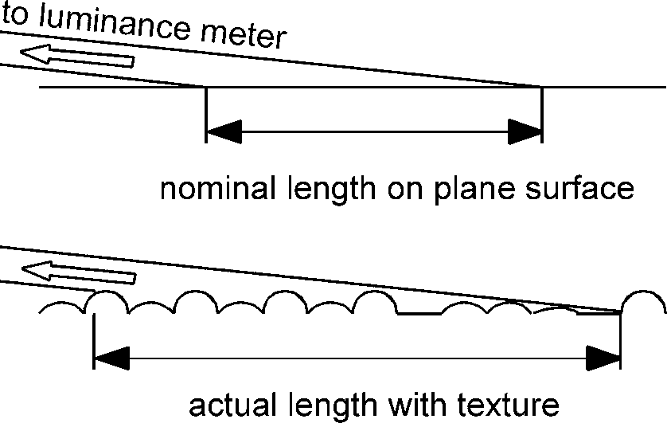
In practice, the illuminated field must cover reserve fields of lengths of 50 mm to 100 mm at both ends.

Fig. 4.1 Lengthening of the measurement field in a surface with texture, caused by blur at the front and back edges of the field.

For the measurement of Qd a surrounding of a uniform luminance can be provided by a photometric sphere as described in Annex A. Illumination to the same effect is not ruled out, but not accounted for either.
Note: The Qd value can be determined to a good accuracy as the weighted average of a few selected q values.
The spectral distribution of a CIE standard illuminant D65 corresponds to daylight conditions, showing that emphasis has been placed on daylight illumination rather than road lighting. This has no significance for road surfaces and road markings of neutral colour and only slight significance for yellow road markings.
For the measurement of R_{L}, the illumination angle ε of 1,24° is justified in section 4.2. The azimuth angle β is 180° according to illumination by the drivers’ own headlamps.
The total angular spread of illumination directions is limited in order to provide well defined measurements. Methods to provide the illumination are described in Annex A.
Note: For the measurement of R_{L}, an arrangement in which the illuminated field is contained within a measurement field of uniform sensitivity can be used. The measured parameter is the intensity of reflected light for which the direct geometrical influence of the angles is avoided, providing better repeatability of the measurement. The R_{L} value at the desired observation and illumination angles is obtained by suitable calibration.
Calibration methods are mentioned in Annex A.

Considerations for in situ measurement of S1
It would be obvious to let the same specifications concerning luminance measurement and the illuminated area apply for S1, as for Qd and R_{L} (drivers’ own headlamps); see Table 4.1.
However, this raises the question of what value of the observation angle α to apply in general. Either the 1° traditionally used for r-tables, or the 2,29° used for in situ measurement of Qd and R_{L}. The general use of α = 2,29° is recommended.
The difficulty of in situ measurements of S1 is described in Annex A.

Considerations for in situ measurement of R_{L} for opposing headlamps
For in situ measurement of the R_{L} for opposing headlamps, it is obvious to apply the same specifications, as for the R_{L} of the drivers’ own headlamps, except that the azimuth angle
β is 0°. See Table 4.1.
It is pointed out that the reserves in the illuminated field have to be relatively large. A position of the equipment 1 mm too high will transpose the measurement area 25 mm one

direction and the illuminated area 46 mm the opposite direction, in total 71 mm relative to each other. For the drivers’ own headlamps, the translations are in the same directions, with a net relative shift of only 16 mm.
Copyrighted material licensed to Toni Bonàs on 2026-05-06 for licensee's use only.
No further reproduction or networking is permitted. Distributed by Accuris, https://accuristech.com.

BIBLIOGRAPHY
ASTM E 1710 Standard test method for measurement of retroreflective pavement marking materials, 1995.
DE BOER, J.B., ONATE, V., & OOSTRIJK, A. Practical methods for measuring and calculating the luminance of road surfaces. Philips Research Report 7, 1952.
BURGHOUT, F. Kenngrössen der Reflexionseigenschaften von trockenen Fahrbahndecken.
Lichttechnik 29, 1977.
CIE 16-1970 Daylight.
CIE 47-1979 Road lighting for wet conditions.
CIE 54.2-2001 Retroreflection: definition and measurement.
CIE 66-1984 Road surfaces and lighting (joint technical report CIE/PIARC).
CIE 69-1987 Methods of characterizing illuminance and luminance meters: Performance, characteristics and specifications.
CIE 73-1988 Visual aspects of road markings (joint CIE/PIARC report).
CIE 115-1995 Recommendations for the lighting of roads for motor and pedestrian traffic.
CIE 140-2000 Road lighting calculations.
EN 1436 Road marking materials - Performance for road users, 1997.
ISO 10526:1999/CIE S005-1998 CIE standard illuminants for colorimetry, 1999. KROCHMANN, J. Über die Horizontalbeleuchtungsstärke der Tagesbeleuchtung. Lichttechnik
15, 11, 559-563, 1963.
KROCHMANN, J., MÜLLER, K., & RETZOW, U. Über die Horizontalbeleuchtungsstärke und die Zenithleuchtdichte des klaren Himmels. Lichttechnik 22, 11, 551-554, 1970.
Night Traffic report 4. Reflection properties of road surfaces in headlight illumination. DELTA Light & Optics, 1982.
Night Traffic report 6. Reflection properties of road markings in headlight illumination. DELTA Light & Optics, 1983.
SØRENSEN, K. Description and classification of light reflection properties of road surfaces. The Danish Illuminating Engineering Laboratory Report 7, 1974.
SØRENSEN, K., & LUNDKVIST, S.O. A model for the specular reflection of road surfaces.
DELTA Light & Optics Note. 2, 1990.
VEDAM, K & STOUDT, M. D. Retroreflection from spherical glass beads in highway pavement markings (in two parts), Applied Optics 17, p. 1855 and p. 1859, 1978.
VIDAL, P.A.B. New system of identification of the reflection indicatrices of pavements. note to CIE TC 4-25, 1996.

ANNEX A - METHODS FOR IN SITU MEASUREMENT
Copyrighted material licensed to Toni Bonàs on 2026-05-06 for licensee's use only.
No further reproduction or networking is permitted. Distributed by Accuris, https://accuristech.com.

Luminance measurement
Limitations of angular spreads require sufficient measurement distances, which may be set directly or simulated optically. The two methods may be called respectively focussed and collimated and can be obtained by use of a luminance meter as indicated in Figures A.1 and A.2.
The main components of a luminance meter are a lens (the objective lens), a sensitive surface (a photo-sensitive surface possibly defined by an aperture) and an entrance aperture.
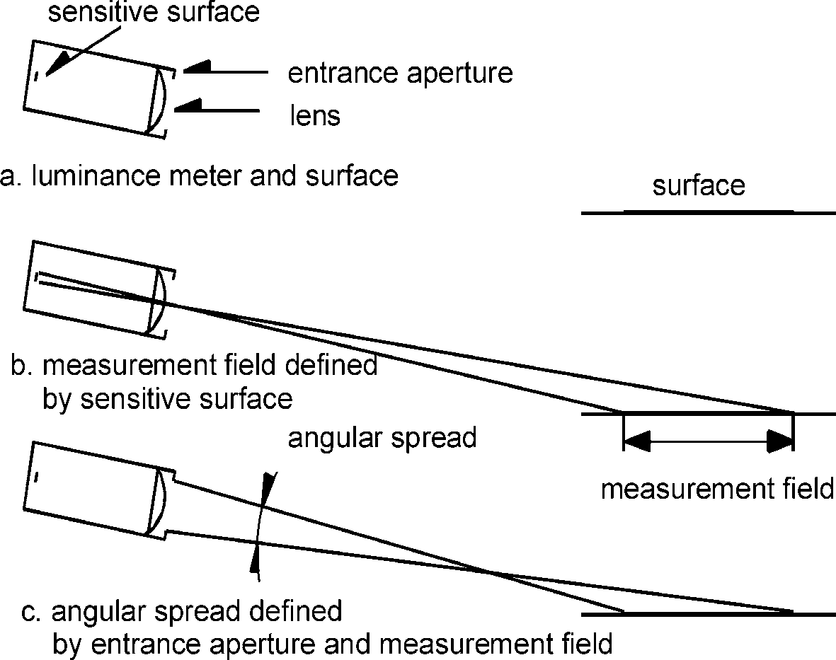
In the focussed method, the luminance meter is placed at a distance and focussed on the field to define the measurement field as sharply as possible (the nearest and farthest point is slightly out of focus). The angular spread is determined by the entrance aperture and the measurement field, also relative to the distance.

Fig. A.1 Focussed luminance measurement. A luminance meter is placed at a distance from the surface.

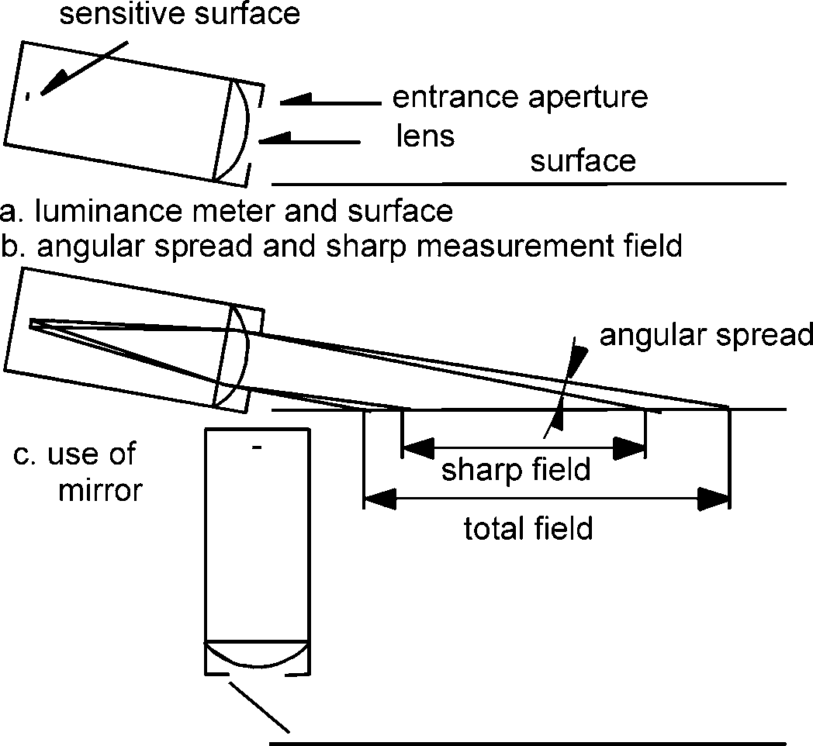
Fig. A.2 Collimated luminance measurement. A luminance meter is placed close to the surface.

In the collimated method, the luminance meter is placed close to the measurement field, its size is determined by the entrance aperture. The luminance meter is focussed on the infinite and the angular spread is defined by the angular subtense of the sensitive surface.
Copyrighted material licensed to Toni Bonàs on 2026-05-06 for licensee's use only.
No further reproduction or networking is permitted. Distributed by Accuris, https://accuristech.com.
The focussed method is suitable when sufficient distance is available as in full scale measurements on the road and in some vehicle mounted equipment. The collimated method, on the other hand, is suitable when space is limited as for portable equipment and some vehicle mounted equipment.
When using a focussed luminance meter with a circular sensitive surface, the length of measurement area will be appr. 25 times the width. Commercially available luminance meters with a measurement field of a diameter of 0,33° (20') are suitable.
With the collimated luminance method, it is convenient to let the measurement area be relatively narrow, for instance 40 mm, so that the lens of the luminance meter does not need to be very large. A length of 200 mm can be achieved with an entrance aperture of a height of 8 mm.

Diffuse illumination for the measurement of Qd
In stationary full scale measurement or dynamic measurement by vehicle mounted equipment, the illumination from the overcast sky can be used to approximate diffuse illumination.
Table 2.6 gives an impression of the uncertainty of the approximation. If the reflection class is known or can be estimated, a correction can be applied according to Table 2.6. As most dry road surfaces and road markings belong to the classes CII, RII, RIII, NII or NIII, the resulting value will mostly be 3% to 7% too low. An average correction of 5% should be applied if the reflection class is not known.
The uncertainty is larger, when parts of the overcast sky are obscured by landscape, vegetation or buildings. This may cause the measured value to be too low or too high depending on what parts of the sky are obscured. If such parts are mainly in the measuring direction, the measured values may be significantly too low due to suppression of specular illumination.
Direct sunlight makes the measured value depend strongly on the position of the sun. A clear sky has luminance variations, even when direct sunlight is avoided, that also makes the measured value depend on circumstances. In either case, the measured value gives an unreliable representation of Qd.
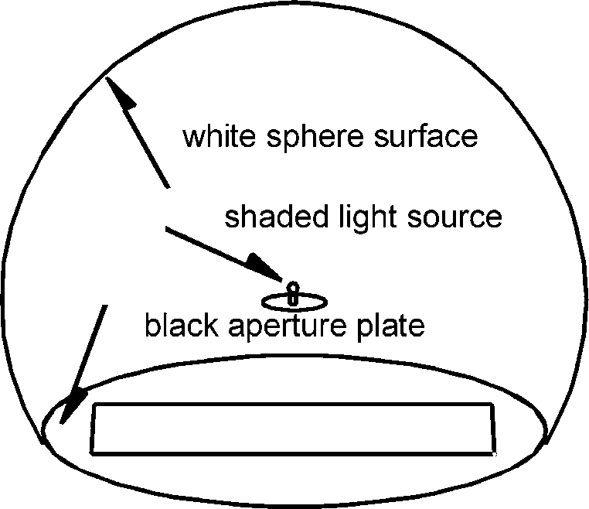
For portable equipment, diffuse illumination can be provided from an aperture of an illuminated, photometric sphere as shown in Fig. A.3.

Fig. A.3 Photometric sphere to provide diffuse illumination through an aperture.
The interior sphere surface is white, illuminated by a shaded light source and closed by a black plate with the aperture.

The sphere is not complete, being closed by a horizontal plate with an aperture for the illumination of the surface to be measured. The interior sphere surface is of white, mat finish, while the upper surface of the plate is black.
Copyrighted material licensed to Toni Bonàs on 2026-05-06 for licensee's use only.
No further reproduction or networking is permitted. Distributed by Accuris, https://accuristech.com.
The sphere is illuminated directly to a reasonably good uniformity by a light source in the centre, which is shaded so as not to illuminate the aperture. A fraction of the direct luminous flux is reflected onto the sphere surface to create a uniform and strong indirect illumination, raising both the uniformity and the level of luminance of the sphere.
Note: When the sphere is a fraction f of a full sphere and the reflectance is ρ, interreflection within the sphere causes an increase of the luminance of the sphere by a factor of 1/(1-ρ·f) compared to direct illumination.
When the sphere has a uniform luminance all locations in the aperture receive diffuse illumination of constant illuminance. To avoid shadows from the aperture plate, the edges of the plate might be sharpened and the aperture itself should be somewhat larger than the intended illuminated field.
The surface in the aperture reflects incoming light back into the sphere, thereby raising its luminance. This effect is insignificant, if the sphere is very much larger than the aperture, but it is more practical to use a sphere of a moderate size for portable equipment. If so, the illuminance on the aperture depends on the surface itself and should be measured as an integral part of the measurement procedure. The aperture should not extend all the way to the sphere wall as this would produce local disturbances of the luminance.

Directional illumination for the measurement of R_{L}
In full scale measurement on the road and in some vehicle mounted equipment, directional illumination can be provided by a lamp at such a distance and with such dimensions that angular spreads are limited according to specifications. A focussed luminance meter can be placed above the lamp for the measurement of the luminance.
The lamp should be so powerful as to create a suitably high luminance, perhaps its luminous intensity should be several times 100 000 cd for full scale measurement. Daylight, road lighting and other false light should be avoided by measuring in darkness, or by using pulsed illumination and elimination of constant signals by electronic filtering.
When space is limited as for portable equipment and some vehicle mounted equipment, a collimated method similar to the one for luminance measurements can be used. The principle is similar to that shown in Fig. A.2, except that the photo-sensitive surface is replaced by a luminous surface, which in practice is an illuminated aperture.
The realization of the collimated illumination causes physical conflict to the surface, it can be avoided by the use of a mirror as shown in Fig. A.2. When this mirror is semi-transparent, a collimated luminance meter can be placed behind the illumination system as shown in Fig. A.4.

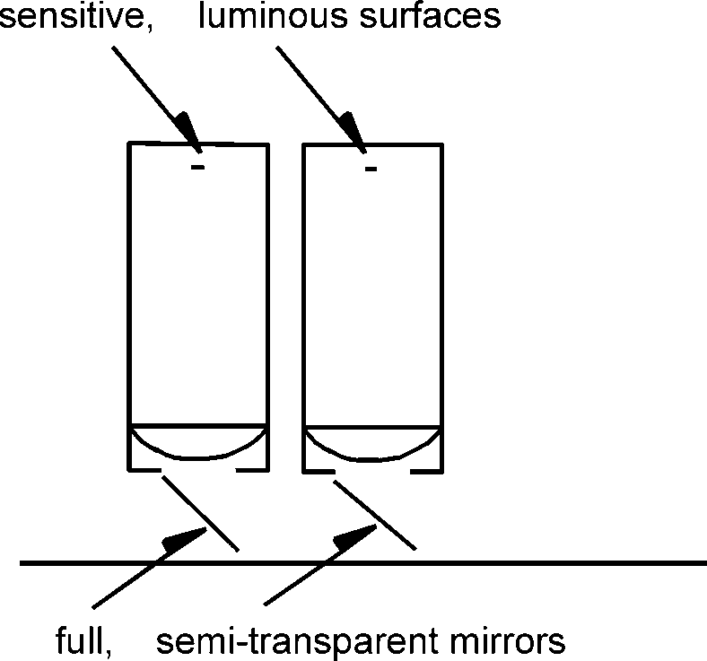
Fig. A.4 Use of a semi-tranparent mirror to allow two collimated systems for measurement and illumination behind each other.

Directional illumination for the measurement of S1
Copyrighted material licensed to Toni Bonàs on 2026-05-06 for licensee's use only.
No further reproduction or networking is permitted. Distributed by Accuris, https://accuristech.com.
The difficulty of in situ measurement of S1 lies with illuminating a field of a length of say 300 mm to 400 mm according to specifications. Either the illumination distance must be quite large, or large lenses must be used to create collimated illumination. Large distances are not directly available, but might be obtained by folding the path of illumination with mirrors. Large lenses are expensive, but might be obtained.
Note: This difficulty does not apply to the measurement of Qd where a relatively small sphere can supply the illumination. It does not apply either for the measurement of R_{L} where the apparent area to be illuminated is small due to the small value of the illumination angle.

Calibration
Calibration can be made by determining the illuminance at the measured field and simultaneously use a calibrated luminance meter. This is adequate for full scale measurement on the road and for laboratory conditions.
For some portable and vehicle mounted equipment, calibration is done by measurement on samples, their characteristic values have been determined in the laboratory. This method does have advantages, but also the disadvantage that the samples are exposed to conditions on the road and must be taken to the laboratory for recalibration.
For Qd, a different type of standard is a unit comprising a mirror and a horizontal opal plate, where the mirror reflects the direction of measurement upwards onto the lower side of the opal plate. The Qd of the unit is τ·1000/π mcd·m⁻²·lx⁻¹, where τ is the transmittance of the optical path. A not too dense opal plate leads to a value of about 100 mcd·m⁻²·lx⁻¹, which is suitable.
For R_{L} a different type of standard is a tilted diffuse reflection standard. A white ceramic surface has an R_{L} value of about 300 mcd·m⁻²·lx⁻¹, which is suitable.
These types of standards must be calibrated in the laboratory as well, but are smaller and sturdier.
Note: If an in situ equipment determines R_{L} on the basis of the intensity of reflected light, the calibration value of a tilted reflection standard must be corrected according to the actual angles of observation and illumination on the surface of the standard.

Laboratory measurement
In the laboratory, space normally allows the use of focussed luminance meters either in a full scale, or in a somewhat reduced scale. Collimated luminance meters are being used as well.
Diffuse illumination for the measurement of Qd values can be provided by placing the sample in a horizontal position in the centre of a large photometric sphere, which is directly illuminated on the lower half and thus indirectly illuminated on the upper half above the surface of the sample.
Directional illumination for the measurement of R_{L} and S1 values can be obtained by lamps placed in suitable distances. Collimated illumination systems are being used as well.
Calibration is normally based on calibrated measurement of illuminance as well as luminance.

ANNEX B - STANDARD REFLECTION TABLES
Copyrighted material licensed to Toni Bonàs on 2026-05-06 for licensee's use only.
No further reproduction or networking is permitted. Distributed by Accuris, https://accuristech.com.
Table C1

 | β (°)
tgγ | 0 | 2 | 5 | 10 | 15 | 20 | 25 | 30 | 35 | 40 | 45 | 60 | 75 | 90 | 105 | 120 | 135 | 150 | 165 | 180
0 | 770 | 770 | 770 | 770 | 770 | 770 | 770 | 770 | 770 | 770 | 770 | 770 | 770 | 770 | 770 | 770 | 770 | 770 | 770 | 770
0,25 | 710 | 708 | 703 | 710 | 712 | 710 | 708 | 708 | 707 | 704 | 702 | 708 | 698 | 702 | 704 | 714 | 708 | 724 | 719 | 723
0,5 | 586 | 582 | 587 | 581 | 581 | 576 | 570 | 567 | 564 | 556 | 548 | 541 | 531 | 544 | 546 | 562 | 566 | 587 | 581 | 589
0,75 | 468 | 467 | 465 | 455 | 457 | 446 | 430 | 420 | 410 | 399 | 390 | 383 | 373 | 384 | 391 | 412 | 419 | 437 | 438 | 445
1 | 378 | 372 | 373 | 363 | 347 | 331 | 314 | 299 | 285 | 273 | 263 | 260 | 250 | 265 | 278 | 295 | 305 | 318 | 323 | 329
1,25 | 308 | 304 | 305 | 285 | 270 | 244 | 218 | 203 | 193 | 185 | 179 | 173 | 173 | 183 | 194 | 207 | 224 | 237 | 238 | 245
1,5 | 258 | 254 | 251 | 229 | 203 | 178 | 157 | 143 | 134 | 128 | 124 | 120 | 120 | 132 | 140 | 155 | 163 | 177 | 179 | 184
1,75 | 217 | 214 | 205 | 182 | 153 | 129 | 110 | 100 | 95 | 90 | 87 | 84 | 88 | 98 | 103 | 116 | 123 | 134 | 137 | 138
2 | 188 | 181 | 174 | 142 | 116 | 95 | 80 | 73 | 69 | 64 | 62 | 64 | 64 | 72 | 78 | 88 | 95 | 105 | 108 | 109
2,5 | 145 | 136 | 121 | 90 | 66 | 53 | 46 | 41 | 39 | 37 | 36 | 36 | 39 | 44 | 50 | 55 | 60 | 66 | 69 | 71
3 | 118 | 108 | 87 | 57 | 41 | 32 | 28 | 26 | 25 | 23 | 22 | 23 | 25 | 28 | 31 | 37 | 41 | 45 | 47 | 51
3,5 | 97 | 87 | 64 | 39 | 26 | 20 | 18 | 17 | 16 | 15 | 15 | 16 | 17 | 19 | 23 | 27 | 30 | 33 | 35 | 37
4 | 80 | 69 | 50 | 29 | 17 | 14 | 13 | 12 | 11 | 11 | 11 | 11 | 13 | 15 | 17 | 19 | 22 | 26 | 27 | 29
4,5 | 70 | 58 | 37 | 21 | 13 | 10 | 9 | 8 | 8 | 8 | 8 | 9 | 10 | 12 | 14 | 16 | 17 | 20 | 21 | 22
5 | 60 | 51 | 29 | 15 | 9 | 7 | 7 | 6 | 6 | 6 | 6 | 7 | 7 | 9 | 10 | 12 | 14 | 17 | 17 | 18
5,5 | 52 | 41 | 23 | 12 | 7 | 6 | 6 | 6 | 5 | 4
6 | 48 | 36 | 19 | 8 | 6 | 5 | 5 | 5 | 5
6,5 | 44 | 32 | 17 | 7 | 6 | 5 | 5 | 5
7 | 41 | 28 | 14 | 6 | 5 | 4 | 4 | 4
7,5 | 37 | 26 | 12 | 6 | 4 | 3 | 3
8 | 34 | 23 | 11 | 5 | 4 | 3 | 3
8,5 | 32 | 21 | 9 | 5 | 4 | 3 | 3
9 | 29 | 19 | 8 | 4 | 3 | 3
9,5 | 27 | 17 | 7 | 4 | 3 | 3
10 | 26 | 16 | 6 | 3 | 3 | 3
10,5 | 25 | 16 | 6 | 3 | 2 | 1 | Table C1 Qd/Q0 = 0,090/0,100 S1=0,24
11 | 23 | 15 | 6 | 3 | 2 | 1
11,5 | 22 | 14 | 6 | 3 | 2
12 | 21 | 14 | 5 | 3 | 2

Table C2

 | β (°)
tgγ | 0 | 2 | 5 | 10 | 15 | 20 | 25 | 30 | 35 | 40 | 45 | 60 | 75 | 90 | 105 | 120 | 135 | 150 | 165 | 180
0 | 329 | 329 | 329 | 329 | 329 | 329 | 329 | 329 | 329 | 329 | 329 | 329 | 329 | 329 | 329 | 329 | 329 | 329 | 329 | 329
0,25 | 362 | 358 | 371 | 364 | 371 | 369 | 362 | 357 | 351 | 349 | 348 | 340 | 328 | 312 | 299 | 294 | 298 | 288 | 292 | 281
0,5 | 379 | 368 | 375 | 373 | 367 | 359 | 350 | 340 | 328 | 317 | 306 | 280 | 266 | 249 | 237 | 237 | 231 | 231 | 227 | 235
0,75 | 380 | 375 | 378 | 365 | 351 | 334 | 315 | 295 | 275 | 256 | 239 | 218 | 198 | 178 | 175 | 176 | 176 | 169 | 175 | 176
1 | 372 | 375 | 372 | 354 | 315 | 277 | 243 | 221 | 205 | 192 | 181 | 152 | 134 | 130 | 125 | 124 | 125 | 129 | 128 | 128
1,25 | 375 | 373 | 352 | 318 | 265 | 221 | 189 | 166 | 150 | 136 | 125 | 107 | 91 | 93 | 91 | 91 | 88 | 94 | 97 | 97
1,5 | 354 | 352 | 336 | 271 | 213 | 170 | 140 | 121 | 109 | 97 | 87 | 76 | 67 | 65 | 66 | 66 | 67 | 68 | 71 | 71
1,75 | 333 | 327 | 302 | 222 | 166 | 129 | 104 | 90 | 75 | 68 | 63 | 53 | 51 | 49 | 49 | 47 | 52 | 51 | 53 | 54
2 | 318 | 310 | 266 | 180 | 121 | 90 | 75 | 62 | 54 | 50 | 48 | 40 | 40 | 38 | 38 | 38 | 41 | 41 | 43 | 45
2,5 | 268 | 262 | 205 | 119 | 72 | 50 | 41 | 36 | 33 | 29 | 26 | 25 | 23 | 24 | 25 | 24 | 26 | 27 | 29 | 28
3 | 227 | 217 | 147 | 74 | 42 | 29 | 25 | 23 | 21 | 19 | 18 | 16 | 16 | 17 | 18 | 17 | 19 | 21 | 21 | 23
3,5 | 194 | 168 | 106 | 47 | 30 | 22 | 17 | 14 | 13 | 12 | 12 | 11 | 10 | 11 | 12 | 13 | 15 | 14 | 15 | 14
4 | 168 | 136 | 76 | 34 | 19 | 14 | 13 | 11 | 10 | 10 | 10 | 8 | 8 | 9 | 10 | 9 | 11 | 12 | 11 | 13
4,5 | 141 | 111 | 54 | 21 | 14 | 11 | 9 | 8 | 8 | 8 | 8 | 7 | 7 | 8 | 8 | 8 | 8 | 10 | 10 | 11
5 | 126 | 90 | 43 | 17 | 10 | 8 | 8 | 7 | 6 | 6 | 7 | 6 | 7 | 6 | 6 | 7 | 8 | 8 | 8 | 9
5,5 | 107 | 79 | 32 | 12 | 8 | 7 | 7 | 7 | 6 | 5
6 | 94 | 65 | 26 | 10 | 7 | 6 | 6 | 6 | 5
6,5 | 86 | 56 | 21 | 8 | 7 | 6 | 5 | 5
7 | 78 | 50 | 17 | 7 | 5 | 5 | 5 | 5
7,5 | 70 | 41 | 14 | 7 | 4 | 3 | 4
8 | 63 | 37 | 11 | 5 | 4 | 4 | 4
8,5 | 60 | 37 | 10 | 5 | 4 | 4 | 4
9 | 56 | 32 | 9 | 5 | 4 | 3
9,5 | 53 | 28 | 9 | 4 | 4 | 4
10 | 52 | 27 | 7 | 5 | 4 | 3
10,5 | 45 | 23 | 7 | 4 | 3 | 3 | Table C2 Qd/Q0 = 0,054/0,070 S1 = 0,97
11 | 43 | 22 | 7 | 3 | 3 | 3
11,5 | 44 | 22 | 7 | 3 | 3
12 | 42 | 20 | 7 | 4 | 3

Table R1
Copyrighted material licensed to Toni Bonàs on 2026-05-06 for licensee's use only.
No further reproduction or networking is permitted. Distributed by Accuris, https://accuristech.com.

 | β (°)
tgγ | 0 | 2 | 5 | 10 | 15 | 20 | 25 | 30 | 35 | 40 | 45 | 60 | 75 | 90 | 105 | 120 | 135 | 150 | 165 | 180
0 | 655 | 655 | 655 | 655 | 655 | 655 | 655 | 655 | 655 | 655 | 655 | 655 | 655 | 655 | 655 | 655 | 655 | 655 | 655 | 655
0,25 | 619 | 619 | 619 | 619 | 610 | 610 | 610 | 610 | 610 | 610 | 610 | 610 | 610 | 601 | 601 | 601 | 601 | 601 | 601 | 601
0,5 | 539 | 539 | 539 | 539 | 539 | 539 | 521 | 521 | 521 | 521 | 521 | 503 | 503 | 503 | 503 | 503 | 503 | 503 | 503 | 503
0,75 | 431 | 431 | 431 | 431 | 431 | 431 | 431 | 431 | 431 | 431 | 395 | 386 | 371 | 371 | 371 | 371 | 371 | 386 | 395 | 395
1 | 341 | 341 | 341 | 341 | 323 | 323 | 305 | 296 | 287 | 287 | 278 | 269 | 269 | 269 | 269 | 269 | 269 | 278 | 278 | 278
1,25 | 269 | 269 | 269 | 260 | 251 | 242 | 224 | 207 | 198 | 189 | 189 | 180 | 180 | 180 | 180 | 180 | 189 | 198 | 207 | 224
1,5 | 224 | 224 | 224 | 215 | 198 | 180 | 171 | 162 | 153 | 148 | 144 | 144 | 139 | 139 | 139 | 144 | 148 | 153 | 162 | 180
1,75 | 189 | 189 | 189 | 171 | 153 | 139 | 130 | 121 | 117 | 112 | 108 | 103 | 99 | 99 | 103 | 108 | 112 | 121 | 130 | 139
2 | 162 | 162 | 157 | 135 | 117 | 108 | 99 | 94 | 90 | 85 | 85 | 83 | 84 | 84 | 86 | 90 | 94 | 99 | 103 | 111
2,5 | 121 | 121 | 117 | 95 | 79 | 66 | 60 | 57 | 54 | 52 | 51 | 50 | 51 | 52 | 54 | 58 | 61 | 65 | 69 | 75
3 | 94 | 94 | 86 | 66 | 49 | 41 | 38 | 36 | 34 | 33 | 32 | 31 | 31 | 33 | 35 | 38 | 40 | 43 | 47 | 51
3,5 | 81 | 80 | 66 | 46 | 33 | 28 | 25 | 23 | 22 | 22 | 21 | 21 | 22 | 22 | 24 | 27 | 29 | 31 | 34 | 38
4 | 71 | 69 | 55 | 32 | 23 | 20 | 18 | 16 | 15 | 14 | 14 | 14 | 15 | 17 | 19 | 20 | 22 | 23 | 25 | 27
4,5 | 63 | 59 | 43 | 24 | 17 | 14 | 13 | 12 | 12 | 11 | 11 | 11 | 12 | 13 | 14 | 14 | 16 | 17 | 19 | 21
5 | 57 | 52 | 36 | 19 | 14 | 12 | 10 | 9 | 9 | 8,8 | 8,7 | 8,7 | 9 | 10 | 11 | 13 | 14 | 15 | 16 | 16
5,5 | 51 | 47 | 31 | 15 | 11 | 9 | 8,1 | 7,8 | 7,7 | 7,7
6 | 47 | 42 | 25 | 12 | 8,5 | 7,2 | 6,5 | 6,3 | 6,2
6,5 | 43 | 38 | 22 | 10 | 6,7 | 5,8 | 5,2 | 5
7 | 40 | 34 | 18 | 8,1 | 5,6 | 4,8 | 4,4 | 4,2
7,5 | 37 | 31 | 15 | 6,9 | 4,7 | 4 | 3,8
8 | 35 | 28 | 14 | 5,7 | 4 | 3,6 | 3,2
8,5 | 33 | 25 | 12 | 4,8 | 3,6 | 3,1 | 2,9
9 | 31 | 23 | 10 | 4,1 | 3,2 | 2,8
9,5 | 30 | 22 | 9 | 3,7 | 2,8 | 2,5
10 | 29 | 20 | 8,2 | 3,2 | 2,4 | 2,2
10,5 | 28 | 18 | 7,3 | 3 | 2,2 | 1,9 | Table R1 Qd/Q0 = 0,087/0,100 S1 = 0,25
11 | 27 | 16 | 6,6 | 2,7 | 1,9 | 1,7
11,5 | 26 | 15 | 6,1 | 2,4 | 1,7
12 | 25 | 14 | 5,6 | 2,2 | 1,6

Table R2

 | β (°)
tgγ | 0 | 2 | 5 | 10 | 15 | 20 | 25 | 30 | 35 | 40 | 45 | 60 | 75 | 90 | 105 | 120 | 135 | 150 | 165 | 180
0 | 390 | 390 | 390 | 390 | 390 | 390 | 390 | 390 | 390 | 390 | 390 | 390 | 390 | 390 | 390 | 390 | 390 | 390 | 390 | 390
0,25 | 411 | 411 | 411 | 411 | 411 | 411 | 411 | 411 | 411 | 411 | 379 | 368 | 357 | 357 | 346 | 346 | 346 | 335 | 335 | 335
0,5 | 411 | 411 | 411 | 411 | 403 | 403 | 384 | 379 | 370 | 346 | 325 | 303 | 281 | 281 | 271 | 271 | 271 | 260 | 260 | 260
0,75 | 379 | 379 | 379 | 368 | 357 | 346 | 325 | 303 | 281 | 260 | 238 | 216 | 206 | 206 | 206 | 206 | 206 | 206 | 206 | 206
1 | 335 | 335 | 335 | 325 | 292 | 291 | 260 | 238 | 216 | 195 | 173 | 152 | 152 | 152 | 152 | 152 | 141 | 141 | 141 | 141
1,25 | 303 | 303 | 292 | 271 | 238 | 206 | 184 | 152 | 130 | 119 | 108 | 100 | 103 | 106 | 108 | 108 | 114 | 114 | 119 | 119
1,5 | 271 | 271 | 260 | 227 | 179 | 152 | 141 | 119 | 108 | 93 | 80 | 76 | 76 | 80 | 84 | 87 | 89 | 91 | 93 | 95
1,75 | 249 | 238 | 227 | 195 | 152 | 124 | 106 | 91 | 78 | 67 | 61 | 52 | 54 | 58 | 63 | 67 | 69 | 71 | 73 | 74
2 | 227 | 216 | 195 | 152 | 117 | 95 | 80 | 67 | 61 | 52 | 45 | 40 | 41 | 45 | 49 | 52 | 54 | 56 | 57 | 58
2,5 | 195 | 190 | 146 | 110 | 74 | 58 | 48 | 40 | 35 | 30 | 27 | 24 | 26 | 28 | 30 | 33 | 35 | 38 | 40 | 41
3 | 160 | 155 | 115 | 67 | 43 | 33 | 26 | 21 | 18 | 17 | 16 | 16 | 17 | 17 | 18 | 21 | 22 | 24 | 26 | 27
3,5 | 146 | 131 | 87 | 41 | 25 | 18 | 15 | 13 | 12 | 11 | 11 | 11 | 11 | 11 | 12 | 14 | 15 | 17 | 18 | 21
4 | 132 | 113 | 67 | 27 | 15 | 12 | 10 | 9,4 | 8,7 | 8,2 | 7,9 | 7,6 | 7,9 | 8,7 | 9,6 | 11 | 12 | 12 | 15 | 17
4,5 | 118 | 95 | 50 | 20 | 12 | 8,9 | 7,4 | 6,6 | 6,3 | 6,1 | 5,7 | 5,6 | 5,8 | 6,3 | 7,1 | 8,4 | 10 | 12 | 13 | 14
5 | 106 | 81 | 38 | 14 | 8,2 | 6,3 | 5,4 | 5 | 4,8 | 4,7 | 4,5 | 4,4 | 4,8 | 5,2 | 6,2 | 7,4 | 8,5 | 9,5 | 10 | 11
5,5 | 96 | 69 | 29 | 11 | 6,3 | 5,1 | 4,4 | 4,1 | 3,9 | 3,8
6 | 87 | 58 | 22 | 8 | 5 | 3,9 | 3,5 | 3,4 | 3,2
6,5 | 78 | 50 | 17 | 6,1 | 3,8 | 3,1 | 2,5 | 2,3 | 2,2
7 | 71 | 43 | 14 | 4,9 | 3,1 | 2,5 | 2,3 | 2,2
7,5 | 67 | 38 | 12 | 4,1 | 2,6 | 2,1 | 1,9
8 | 63 | 33 | 10 | 3,4 | 2,2 | 1,8 | 1,7
8,5 | 58 | 28 | 8,7 | 2,9 | 1,9 | 1,6 | 1,5
9 | 55 | 25 | 7,4 | 2,5 | 1,7 | 1,4
9,5 | 52 | 23 | 6,5 | 2,2 | 1,5 | 1,3
10 | 49 | 21 | 5,6 | 1,9 | 1,4 | 1,2
10,5 | 47 | 18 | 5 | 1,7 | 1,3 | 1,2 | Table R2 Qd/Q0 = 0,057/0,070 S1 = 0,58
11 | 44 | 16 | 4,4 | 1,6 | 1,2 | 1,1
11,5 | 42 | 14 | 4 | 1,5 | 1,1
12 | 41 | 13 | 3,6 | 1,4 | 1,1

Table R3
Copyrighted material licensed to Toni Bonàs on 2026-05-06 for licensee's use only.
No further reproduction or networking is permitted. Distributed by Accuris, https://accuristech.com.

 | β (°)
tgγ | 0 | 2 | 5 | 10 | 15 | 20 | 25 | 30 | 35 | 40 | 45 | 60 | 75 | 90 | 105 | 120 | 135 | 150 | 165 | 180
0 | 294 | 294 | 294 | 294 | 294 | 294 | 294 | 294 | 294 | 294 | 294 | 294 | 294 | 294 | 294 | 294 | 294 | 294 | 294 | 294
0,25 | 326 | 326 | 321 | 321 | 317 | 312 | 308 | 308 | 303 | 298 | 294 | 280 | 271 | 262 | 258 | 253 | 249 | 244 | 240 | 240
0,5 | 344 | 344 | 339 | 339 | 326 | 317 | 308 | 298 | 289 | 276 | 262 | 235 | 217 | 204 | 199 | 199 | 199 | 199 | 194 | 194
0,75 | 357 | 353 | 353 | 339 | 321 | 303 | 285 | 267 | 244 | 222 | 204 | 176 | 158 | 149 | 149 | 149 | 145 | 136 | 136 | 140
1 | 362 | 362 | 352 | 326 | 276 | 249 | 226 | 204 | 181 | 158 | 140 | 118 | 104 | 100 | 100 | 100 | 100 | 100 | 100 | 100
1,25 | 357 | 357 | 348 | 298 | 244 | 208 | 176 | 154 | 136 | 118 | 104 | 83 | 73 | 70 | 71 | 74 | 77 | 77 | 77 | 78
1,5 | 353 | 348 | 326 | 267 | 217 | 176 | 145 | 117 | 100 | 86 | 78 | 72 | 60 | 57 | 58 | 60 | 60 | 60 | 61 | 62
1,75 | 339 | 335 | 303 | 231 | 172 | 127 | 104 | 89 | 79 | 70 | 62 | 51 | 45 | 44 | 45 | 46 | 45 | 45 | 46 | 47
2 | 326 | 321 | 280 | 190 | 136 | 100 | 82 | 71 | 62 | 54 | 48 | 39 | 34 | 34 | 34 | 35 | 36 | 36 | 37 | 38
2,5 | 289 | 280 | 222 | 127 | 86 | 65 | 54 | 44 | 38 | 34 | 25 | 23 | 22 | 23 | 24 | 24 | 24 | 24 | 24 | 25
3 | 253 | 235 | 163 | 85 | 53 | 38 | 31 | 25 | 23 | 20 | 18 | 15 | 15 | 14 | 15 | 15 | 16 | 16 | 17 | 17
3,5 | 217 | 194 | 122 | 60 | 35 | 25 | 22 | 19 | 16 | 15 | 13 | 9,9 | 9 | 9 | 9,9 | 11 | 11 | 12 | 12 | 13
4 | 190 | 163 | 90 | 43 | 26 | 20 | 16 | 14 | 12 | 9,9 | 9 | 7,4 | 7 | 7,1 | 7,5 | 8,3 | 8,7 | 9 | 9 | 9,9
4,5 | 163 | 136 | 73 | 31 | 20 | 15 | 12 | 9,9 | 9 | 8,3 | 7,7 | 5,4 | 4,8 | 4,9 | 5,4 | 6,1 | 7 | 7,7 | 8,3 | 8,5
5 | 145 | 109 | 60 | 24 | 16 | 12 | 9 | 8,2 | 7,7 | 6,8 | 6,1 | 4,3 | 3,2 | 3,3 | 3,7 | 4,3 | 5,2 | 6,5 | 6,9 | 7,1
5,5 | 127 | 94 | 47 | 18 | 14 | 9,9 | 7,7 | 6,9 | 6,1 | 5,7
6 | 113 | 77 | 36 | 15 | 11 | 9 | 8 | 6,5 | 5,1
6,5 | 104 | 68 | 30 | 11 | 8,3 | 6,4 | 5,1 | 4,3
7 | 95 | 60 | 24 | 8,5 | 6,5 | 5,2 | 4,3 | 3,4
7,5 | 87 | 53 | 21 | 7,1 | 5,3 | 4,4 | 3,6
8 | 83 | 47 | 17 | 6,1 | 4,4 | 3,6 | 3,1
8,5 | 78 | 42 | 15 | 5,2 | 3,7 | 3,1 | 2,6
9 | 73 | 38 | 12 | 4,3 | 3,2 | 2,4
9,5 | 69 | 34 | 9,9 | 3,8 | 3,5 | 2,2
10 | 65 | 32 | 9 | 3,3 | 2,4 | 2
10,5 | 62 | 29 | 8 | 3 | 2,1 | 1,9 | Table R3 Qd/Q0 = 0,050/0,070 S1 = 1,11
11 | 59 | 26 | 7,1 | 2,6 | 1,9 | 1,8
11,5 | 56 | 24 | 6,3 | 2,4 | 1,8
12 | 53 | 22 | 5,6 | 2,1 | 1,8

Table R4

 | β (°)
tgγ | 0 | 2 | 5 | 10 | 15 | 20 | 25 | 30 | 35 | 40 | 45 | 60 | 75 | 90 | 105 | 120 | 135 | 150 | 165 | 180
0 | 264 | 264 | 264 | 264 | 264 | 264 | 264 | 264 | 264 | 264 | 264 | 264 | 264 | 264 | 264 | 264 | 264 | 264 | 264 | 264
0,25 | 297 | 317 | 317 | 317 | 317 | 310 | 304 | 290 | 284 | 277 | 271 | 244 | 231 | 224 | 224 | 220 | 220 | 211 | 211 | 211
0,5¦ | 330 | 343 | 343 | 343 | 330 | 310 | 297 | 284 | 277 | 264 | 251 | 218 | 198 | 185 | 178 | 172 | 172 | 165 | 165 | 165
0,75 | 376 | 383 | 370 | 350 | 330 | 304 | 277 | 251 | 231 | 211 | 198 | 165 | 139 | 132 | 132 | 125 | 125 | 125 | 119 | 119
1 | 396 | 396 | 396 | 330 | 290 | 251 | 218 | 198 | 185 | 165 | 145 | 112 | 86 | 86 | 86 | 86 | 86 | 87 | 87 | 87
1,25 | 403 | 409 | 370 | 310 | 251 | 211 | 178 | 152 | 132 | 115 | 103 | 77 | 66 | 65 | 65 | 63 | 65 | 66 | 67 | 68
1,5 | 409 | 396 | 356 | 284 | 218 | 172 | 139 | 115 | 100 | 88 | 79 | 61 | 50 | 50 | 50 | 50 | 52 | 55 | 55 | 55
1,75 | 409 | 396 | 343 | 251 | 178 | 139 | 108 | 88 | 75 | 66 | 59 | 44 | 37 | 37 | 37 | 38 | 40 | 41 | 42 | 45
2 | 409 | 383 | 317 | 224 | 145 | 106 | 86 | 71 | 59 | 53 | 45 | 33 | 29 | 29 | 29 | 30 | 32 | 33 | 34 | 37
2,5 | 396 | 356 | 264 | 152 | 100 | 73 | 55 | 45 | 37 | 32 | 28 | 21 | 20 | 20 | 20 | 21 | 22 | 24 | 25 | 26
3 | 370 | 304 | 211 | 95 | 63 | 44 | 30 | 25 | 21 | 17 | 16 | 13 | 12 | 12 | 13 | 13 | 15 | 16 | 17 | 19
3,5 | 343 | 271 | 165 | 63 | 40 | 26 | 19 | 15 | 13 | 12 | 11 | 9,8 | 9,1 | 8,8 | 8,8 | 9,4 | 11 | 12 | 13 | 15
4 | 317 | 238 | 132 | 45 | 24 | 16 | 13 | 11 | 9,6 | 9 | 8,4 | 7,5 | 7,4 | 7,4 | 7,5 | 7,9 | 8,6 | 9,4 | 11 | 12
4,5 | 297 | 211 | 106 | 33 | 17 | 11 | 9,2 | 7,9 | 7,3 | 6,6 | 6,3 | 6,1 | 6,1 | 6,4 | 6,5 | 6,7 | 7,1 | 7,7 | 8,7 | 9,6
5 | 277 | 185 | 79 | 24 | 13 | 8,3 | 7 | 6,3 | 5,7 | 5,1 | 5 | 5 | 5,1 | 5,4 | 5,5 | 5,8 | 6,1 | 6,3 | 6,9 | 7,7
5,5 | 257 | 161 | 59 | 19 | 9,9 | 7,1 | 5,7 | 5 | 4,6 | 4,2
6 | 244 | 140 | 46 | 13 | 7,7 | 5,7 | 4,8 | 4,1 | 3,8
6,5 | 231 | 122 | 37 | 11 | 5,9 | 4,6 | 3,7 | 3,2
7 | 218 | 106 | 32 | 9 | 5 | 3,8 | 3,2 | 2,6
7,5 | 205 | 94 | 26 | 7,5 | 4,4 | 3,3 | 2,8
8 | 193 | 82 | 22 | 6,3 | 3,7 | 2,9 | 2,4
8,5 | 184 | 74 | 19 | 5,3 | 3,2 | 2,5 | 2,1
9 | 174 | 66 | 16 | 4,6 | 2,8 | 2,1
9,5 | 169 | 59 | 13 | 4,1 | 2,5 | 2
10 | 164 | 53 | 12 | 3,7 | 2,2 | 1,7
10,5 | 158 | 49 | 11 | 3,3 | 2,1 | 1,7 | Table R4 Qd/Q0 = 0,052/0,080 S1 = 1,55
11 | 153 | 45 | 9,5 | 3 | 2 | 1,7
11,5 | 149 | 41 | 8,4 | 2,6 | 1,7
12 | 145 | 37 | 7,7 | 2,5 | 1,7

Table N1
Copyrighted material licensed to Toni Bonàs on 2026-05-06 for licensee's use only.
No further reproduction or networking is permitted. Distributed by Accuris, https://accuristech.com.

 | β (°)
tgγ | 0 | 2 | 5 | 10 | 15 | 20 | 25 | 30 | 35 | 40 | 45 | 60 | 75 | 90 | 105 | 120 | 135 | 150 | 165 | 180
0 | 768 | 768 | 768 | 768 | 768 | 768 | 768 | 768 | 768 | 768 | 768 | 768 | 768 | 768 | 768 | 768 | 768 | 768 | 768 | 768
0,25 | 694 | 694 | 694 | 694 | 694 | 693 | 693 | 693 | 693 | 693 | 695 | 699 | 702 | 714 | 720 | 734 | 741 | 751 | 753 | 757
0,5 | 557 | 557 | 557 | 555 | 554 | 550 | 546 | 544 | 544 | 543 | 543 | 542 | 547 | 564 | 577 | 600 | 615 | 633 | 640 | 646
0,75 | 424 | 424 | 424 | 417 | 415 | 406 | 397 | 392 | 388 | 382 | 378 | 381 | 388 | 407 | 425 | 450 | 469 | 489 | 497 | 505
1 | 323 | 322 | 321 | 310 | 302 | 289 | 278 | 271 | 266 | 261 | 257 | 259 | 266 | 284 | 303 | 328 | 346 | 366 | 375 | 381
1,25 | 252 | 250 | 247 | 234 | 220 | 206 | 193 | 186 | 180 | 176 | 173 | 175 | 183 | 200 | 216 | 237 | 254 | 271 | 279 | 285
1,5 | 202 | 198 | 193 | 177 | 160 | 147 | 135 | 128 | 124 | 121 | 119 | 122 | 129 | 142 | 157 | 175 | 189 | 204 | 212 | 216
1,75 | 164 | 162 | 154 | 134 | 117 | 104 | 94 | 89 | 87 | 84 | 84 | 86 | 93 | 104 | 116 | 131 | 144 | 155 | 162 | 166
2 | 138 | 136 | 126 | 104 | 88 | 76 | 69 | 65 | 63 | 61 | 61 | 63 | 69 | 78 | 88 | 101 | 111 | 121 | 127 | 131
2,5 | 103 | 100 | 86 | 64 | 51 | 43 | 38 | 36 | 35 | 35 | 35 | 37 | 41 | 48 | 55 | 64 | 71 | 79 | 84 | 86
3 | 80 | 75 | 61 | 41 | 31 | 26 | 24 | 22 | 21 | 21 | 21 | 23 | 26 | 31 | 36 | 42 | 48 | 55 | 58 | 60
3,5 | 65 | 60 | 45 | 28 | 21 | 17 | 15 | 15 | 15 | 15 | 15 | 16 | 18 | 21 | 25 | 31 | 35 | 39 | 42 | 44
4 | 55 | 48 | 34 | 20 | 14 | 12 | 11 | 10 | 10 | 10 | 10 | 12 | 13 | 16 | 19 | 23 | 26 | 30 | 32 | 34
4,5 | 47 | 40 | 26 | 14 | 11 | 8 | 8 | 8 | 8 | 8 | 8 | 8 | 10 | 12 | 15 | 18 | 20 | 23 | 25 | 27
5 | 40 | 34 | 20 | 11 | 8 | 6 | 6 | 5 | 5 | 5 | 6 | 6 | 8 | 10 | 12 | 14 | 16 | 18 | 21 | 21
5,5 | 35 | 28 | 15 | 8 | 6 | 5 | 5 | 5 | 5 | 5
6 | 31 | 25 | 13 | 7 | 5 | 4 | 4 | 4 | 4
6,5 | 28 | 21 | 11 | 5 | 4 | 3 | 3 | 3
7 | 25 | 19 | 9 | 5 | 3 | 3 | 3 | 3
7,5 | 23 | 17 | 8 | 4 | 3 | 3 | 3
8 | 21 | 15 | 7 | 4 | 3 | 2 | 2
8,5 | 19 | 14 | 6 | 3 | 2 | 2 | 2
9 | 18 | 13 | 5 | 3 | 2 | 2
9,5 | 17 | 12 | 5 | 2 | 2 | 2
10 | 16 | 11 | 4 | 2 | 2 | 2
10,5 | 15 | 10 | 4 | 2 | 2 | 1 | Table N1 Qd/Q0 = 0,092/0,100 S1 = 0,18
11 | 15 | 9 | 4 | 2 | 2 | 1
11,5 | 14 | 9 | 3 | 2 | 2
12 | 14 | 8 | 3 | 2 | 2

Table N2

 | β (°)
tgγ | 0 | 2 | 5 | 10 | 15 | 20 | 25 | 30 | 35 | 40 | 45 | 60 | 75 | 90 | 105 | 120 | 135 | 150 | 165 | 180
0 | 474 | 474 | 474 | 474 | 474 | 474 | 474 | 474 | 474 | 474 | 474 | 474 | 474 | 474 | 474 | 474 | 474 | 474 | 474 | 474
0,25 | 472 | 471 | 471 | 470 | 470 | 468 | 466 | 464 | 463 | 459 | 456 | 450 | 443 | 439 | 435 | 434 | 434 | 435 | 436 | 436
0,5 | 427 | 426 | 426 | 423 | 418 | 413 | 408 | 399 | 390 | 382 | 375 | 359 | 347 | 343 | 341 | 344 | 348 | 352 | 353 | 356
0,75 | 374 | 372 | 370 | 361 | 349 | 336 | 322 | 309 | 297 | 285 | 275 | 255 | 245 | 244 | 245 | 253 | 256 | 262 | 265 | 268
1 | 326 | 323 | 319 | 303 | 284 | 263 | 243 | 227 | 213 | 202 | 193 | 177 | 170 | 170 | 174 | 180 | 186 | 192 | 196 | 199
1,25 | 284 | 281 | 275 | 251 | 224 | 198 | 176 | 161 | 149 | 139 | 132 | 121 | 117 | 119 | 123 | 129 | 135 | 141 | 145 | 147
1,5 | 249 | 246 | 235 | 203 | 172 | 146 | 127 | 113 | 104 | 97 | 92 | 84 | 83 | 85 | 89 | 94 | 99 | 105 | 108 | 110
1,75 | 219 | 216 | 201 | 162 | 129 | 106 | 91 | 81 | 73 | 68 | 64 | 60 | 59 | 62 | 65 | 70 | 74 | 79 | 82 | 84
2 | 194 | 190 | 171 | 129 | 97 | 78 | 65 | 57 | 53 | 49 | 46 | 44 | 44 | 46 | 49 | 53 | 57 | 61 | 64 | 65
2,5 | 157 | 150 | 124 | 82 | 57 | 44 | 37 | 32 | 30 | 28 | 27 | 26 | 26 | 28 | 30 | 33 | 37 | 40 | 42 | 43
3 | 130 | 120 | 90 | 52 | 35 | 26 | 22 | 19 | 18 | 17 | 17 | 16 | 17 | 18 | 20 | 22 | 24 | 27 | 28 | 29
3,5 | 110 | 98 | 65 | 34 | 22 | 16 | 14 | 13 | 12 | 11 | 11 | 11 | 11 | 12 | 14 | 16 | 18 | 19 | 21 | 21
4 | 94 | 80 | 48 | 23 | 15 | 11 | 9 | 9 | 8 | 8 | 8 | 8 | 8 | 9 | 10 | 12 | 13 | 15 | 16 | 16
4,5 | 80 | 65 | 36 | 17 | 10 | 8 | 7 | 6 | 6 | 6 | 6 | 6 | 6 | 7 | 8 | 9 | 10 | 11 | 12 | 13
5 | 70 | 55 | 28 | 12 | 8 | 6 | 5 | 5 | 4 | 4 | 4 | 4 | 5 | 5 | 6 | 7 | 8 | 9 | 10 | 10
5,5 | 61 | 46 | 22 | 9 | 6 | 4 | 4 | 4 | 3 | 3
6 | 54 | 39 | 18 | 7 | 5 | 4 | 3 | 3 | 3
6,5 | 48 | 34 | 14 | 6 | 4 | 3 | 2 | 2
7 | 43 | 30 | 12 | 5 | 3 | 2 | 2 | 2
7,5 | 39 | 27 | 10 | 4 | 2 | 2 | 2
8 | 36 | 23 | 9 | 3 | 2 | 2 | 1
8,5 | 33 | 21 | 7 | 3 | 2 | 1 | 1
9 | 30 | 18 | 6 | 2 | 1 | 1
9,5 | 28 | 17 | 5 | 2 | 1 | 1
10 | 26 | 16 | 5 | 2 | 1 | 1
10,5 | 25 | 14 | 4 | 1 | 1 | 0 | Table N2 Qd/Q0 = 0,061/0,070 S1 = 0,41
11 | 23 | 13 | 4 | 1 | 1 | 0
11,5 | 22 | 12 | 3 | 1 | 1
12 | 21 | 12 | 3 | 1 | 1

Table N3
Copyrighted material licensed to Toni Bonàs on 2026-05-06 for licensee's use only.
No further reproduction or networking is permitted. Distributed by Accuris, https://accuristech.com.

 | β (°)
tgγ | 0 | 2 | 5 | 10 | 15 | 20 | 25 | 30 | 35 | 40 | 45 | 60 | 75 | 90 | 105 | 120 | 135 | 150 | 165 | 180
0 | 354 | 354 | 354 | 354 | 354 | 354 | 354 | 354 | 354 | 354 | 354 | 354 | 354 | 354 | 354 | 354 | 354 | 354 | 354 | 354
0,25 | 391 | 391 | 390 | 389 | 388 | 385 | 381 | 378 | 373 | 369 | 365 | 351 | 338 | 328 | 319 | 313 | 308 | 306 | 304 | 304
0,5 | 406 | 404 | 403 | 397 | 390 | 379 | 366 | 355 | 343 | 330 | 318 | 291 | 268 | 256 | 247 | 242 | 240 | 240 | 240 | 240
0,75 | 405 | 403 | 399 | 384 | 365 | 342 | 319 | 298 | 278 | 260 | 244 | 213 | 192 | 182 | 176 | 175 | 175 | 176 | 177 | 177
1 | 396 | 392 | 384 | 357 | 322 | 287 | 254 | 228 | 207 | 189 | 175 | 147 | 133 | 126 | 124 | 123 | 125 | 127 | 129 | 130
1,25 | 383 | 374 | 360 | 317 | 269 | 227 | 193 | 168 | 149 | 134 | 123 | 103 | 93 | 89 | 87 | 89 | 91 | 94 | 95 | 96
1,5 | 360 | 351 | 328 | 270 | 215 | 172 | 141 | 119 | 105 | 94 | 86 | 72 | 66 | 63 | 63 | 64 | 67 | 69 | 71 | 72
1,75 | 335 | 325 | 294 | 224 | 165 | 127 | 102 | 86 | 75 | 67 | 61 | 52 | 47 | 46 | 47 | 48 | 50 | 52 | 54 | 55
2 | 312 | 298 | 259 | 182 | 126 | 94 | 75 | 63 | 56 | 50 | 45 | 38 | 35 | 35 | 35 | 37 | 38 | 40 | 42 | 43
2,5 | 270 | 250 | 199 | 120 | 76 | 53 | 43 | 35 | 32 | 28 | 26 | 23 | 22 | 21 | 22 | 23 | 24 | 27 | 28 | 28
3 | 233 | 206 | 148 | 78 | 46 | 31 | 26 | 21 | 19 | 18 | 17 | 15 | 14 | 14 | 15 | 16 | 17 | 18 | 19 | 20
3,5 | 202 | 171 | 109 | 51 | 29 | 20 | 17 | 14 | 13 | 12 | 11 | 10 | 10 | 10 | 11 | 11 | 12 | 13 | 14 | 15
4 | 177 | 142 | 82 | 35 | 20 | 13 | 11 | 10 | 9 | 8 | 8 | 7 | 7 | 7 | 8 | 8 | 9 | 10 | 11 | 11
4,5 | 155 | 118 | 61 | 24 | 14 | 10 | 8 | 7 | 7 | 6 | 6 | 5 | 5 | 6 | 6 | 6 | 7 | 8 | 8 | 9
5 | 137 | 100 | 47 | 18 | 10 | 7 | 6 | 6 | 5 | 5 | 5 | 4 | 4 | 5 | 5 | 5 | 6 | 6 | 7 | 7
5,5 | 121 | 84 | 37 | 13 | 8 | 6 | 5 | 5 | 4 | 3
6 | 108 | 72 | 29 | 11 | 6 | 5 | 4 | 4 | 4
6,5 | 97 | 62 | 24 | 8 | 5 | 4 | 4 | 3
7 | 89 | 55 | 20 | 7 | 4 | 3 | 3 | 3
7,5 | 81 | 49 | 17 | 6 | 4 | 3 | 3
8 | 74 | 43 | 15 | 5 | 3 | 2 | 2
8,5 | 68 | 38 | 12 | 4 | 3 | 2 | 2
9 | 63 | 34 | 11 | 4 | 2 | 2
9,5 | 58 | 31 | 9 | 3 | 2 | 2
10 | 54 | 28 | 8 | 3 | 2 | 2
10,5 | 51 | 26 | 7 | 3 | 2 | 2 | Table N3 Qd/Q0 = 0,054/0,070 S1 = 0,88
11 | 48 | 24 | 6 | 2 | 2 | 2
11,5 | 45 | 22 | 6 | 2 | 1
12 | 43 | 21 | 5 | 2 | 1

Table N4

 | β (°)
tgγ | 0 | 2 | 5 | 10 | 15 | 20 | 25 | 30 | 35 | 40 | 45 | 60 | 75 | 90 | 105 | 120 | 135 | 150 | 165 | 180
0 | 282 | 282 | 282 | 282 | 282 | 282 | 282 | 282 | 282 | 282 | 282 | 282 | 282 | 282 | 282 | 282 | 282 | 282 | 282 | 282
0.25 | 332 | 332 | 331 | 328 | 328 | 324 | 319 | 315 | 311 | 303 | 295 | 280 | 262 | 253 | 247 | 241 | 237 | 231 | 230 | 228
0.5 | 375 | 374 | 373 | 367 | 358 | 345 | 331 | 318 | 305 | 287 | 271 | 242 | 209 | 196 | 189 | 184 | 180 | 177 | 176 | 175
0.75 | 412 | 411 | 406 | 388 | 361 | 337 | 314 | 284 | 256 | 235 | 218 | 182 | 153 | 142 | 138 | 135 | 132 | 130 | 130 | 130
1 | 441 | 438 | 426 | 385 | 341 | 294 | 251 | 220 | 196 | 174 | 156 | 126 | 106 | 97 | 94 | 94 | 93 | 94 | 94 | 95
1,25 | 459 | 453 | 430 | 365 | 299 | 243 | 198 | 168 | 146 | 128 | 115 | 91 | 76 | 71 | 68 | 69 | 69 | 70 | 71 | 72
1,5 | 466 | 456 | 417 | 326 | 246 | 189 | 149 | 122 | 105 | 92 | 83 | 67 | 56 | 53 | 52 | 52 | 53 | 54 | 55 | 55
1,75 | 464 | 449 | 392 | 284 | 199 | 146 | 114 | 92 | 79 | 69 | 63 | 50 | 42 | 40 | 39 | 40 | 41 | 42 | 43 | 44
2 | 453 | 431 | 356 | 234 | 153 | 108 | 85 | 69 | 60 | 52 | 46 | 37 | 32 | 30 | 30 | 30 | 31 | 32 | 33 | 34
2,5 | 425 | 387 | 283 | 152 | 93 | 64 | 50 | 41 | 36 | 31 | 28 | 23 | 20 | 19 | 19 | 19 | 20 | 21 | 23 | 23
3 | 385 | 333 | 211 | 98 | 57 | 38 | 30 | 25 | 22 | 19 | 17 | 14 | 13 | 12 | 12 | 13 | 14 | 14 | 15 | 16
3,5 | 349 | 286 | 158 | 66 | 37 | 25 | 20 | 17 | 15 | 13 | 12 | 10 | 9 | 8 | 9 | 9 | 10 | 10 | 12 | 12
4 | 316 | 245 | 117 | 47 | 27 | 18 | 14 | 12 | 11 | 10 | 9 | 7 | 6 | 6 | 6 | 7 | 8 | 8 | 9 | 9
4,5 | 286 | 207 | 88 | 33 | 20 | 14 | 11 | 9 | 8 | 7 | 7 | 6 | 6 | 5 | 5 | 6 | 6 | 7 | 7 | 8
5 | 260 | 175 | 69 | 24 | 15 | 10 | 8 | 7 | 6 | 6 | 5 | 5 | 5 | 4 | 4 | 5 | 5 | 5 | 6 | 6
5,5 | 237 | 147 | 54 | 19 | 12 | 8 | 6 | 6 | 5 | 5
6 | 216 | 162 | 43 | 15 | 9 | 6 | 5 | 5 | 4
6,5 | 198 | 108 | 35 | 12 | 7 | 5 | 5 | 4
7 | 184 | 95 | 28 | 9 | 6 | 5 | 4 | 2
7,5 | 169 | 85 | 23 | 8 | 5 | 4 | 3
8 | 158 | 75 | 20 | 7 | 4 | 3 | 3
8,5 | 148 | 68 | 17 | 6 | 4 | 3 | 3
9 | 138 | 61 | 14 | 5 | 3 | 2
9,5 | 131 | 55 | 12 | 4 | 3 | 2
10 | 126 | 50 | 11 | 4 | 2 | 2
10,5 | 118 | 46 | 10 | 3 | 2 | 2 | Table N4 Qd/Q0 = 0,054/0,080 S1 = 1,61
11 | 110 | 42 | 8 | 3 | 2 | 2
11,5 | 103 | 39 | 8 | 3 | 2
12 | 98 | 36 | 7 | 2 | 2

Table W1
Copyrighted material licensed to Toni Bonàs on 2026-05-06 for licensee's use only.
No further reproduction or networking is permitted. Distributed by Accuris, https://accuristech.com.

 | β (°)
tgγ | 0 | 2 | 5 | 10 | 15 | 20 | 25 | 30 | 35 | 40 | 45 | 60 | 75 | 90 | 105 | 120 | 135 | 150 | 165 | 180
0 | 394 | 394 | 394 | 394 | 394 | 394 | 394 | 394 | 394 | 394 | 394 | 394 | 394 | 394 | 394 | 394 | 394 | 394 | 394 | 394
0,25 | 426 | 426 | 426 | 425 | 423 | 418 | 413 | 409 | 405 | 398 | 391 | 377 | 363 | 355 | 351 | 350 | 348 | 350 | 350 | 352
0,5 | 501 | 499 | 494 | 481 | 459 | 435 | 412 | 389 | 367 | 346 | 326 | 292 | 272 | 266 | 264 | 270 | 273 | 279 | 282 | 284
0,75 | 648 | 641 | 622 | 576 | 512 | 444 | 385 | 339 | 298 | 267 | 239 | 198 | 183 | 183 | 187 | 195 | 200 | 209 | 212 | 216
1 | 833 | 818 | 773 | 651 | 523 | 411 | 323 | 262 | 212 | 183 | 158 | 128 | 121 | 124 | 130 | 138 | 145 | 152 | 156 | 159
1,25 | 1006 | 976 | 882 | 676 | 484 | 343 | 242 | 187 | 145 | 121 | 102 | 84 | 81 | 85 | 91 | 98 | 105 | 112 | 115 | 117
1,5 | 1138 | 1084 | 930 | 634 | 402 | 265 | 175 | 129 | 95 | 79 | 66 | 56 | 56 | 60 | 65 | 72 | 77 | 83 | 86 | 88
1,75 | 1218 | 1141 | 935 | 554 | 317 | 194 | 119 | 87 | 63 | 53 | 45 | 39 | 39 | 44 | 48 | 53 | 58 | 63 | 65 | 67
2 | 1242 | 1143 | 877 | 460 | 243 | 142 | 83 | 60 | 43 | 37 | 31 | 28 | 29 | 32 | 36 | 41 | 45 | 48 | 51 | 53
2,5 | 1184 | 1042 | 696 | 293 | 138 | 75 | 41 | 30 | 22 | 19 | 17 | 16 | 17 | 20 | 22 | 26 | 28 | 31 | 34 | 35
3 | 1057 | 876 | 493 | 178 | 74 | 40 | 22 | 17 | 13 | 11 | 10 | 10 | 11 | 13 | 15 | 17 | 19 | 22 | 23 | 24
3,5 | 914 | 710 | 340 | 105 | 41 | 23 | 13 | 10 | 8 | 7 | 7 | 7 | 8 | 9 | 11 | 12 | 14 | 16 | 17 | 18
4 | 770 | 548 | 230 | 65 | 22 | 13 | 8 | 7 | 6 | 5 | 5 | 5 | 6 | 7 | 8 | 9 | 11 | 12 | 13 | 13
4,5 | 627 | 411 | 156 | 40 | 14 | 9 | 6 | 5 | 4 | 4 | 4 | 4 | 4 | 5 | 6 | 7 | 8 | 9 | 10 | 11
5 | 508 | 315 | 109 | 26 | 9 | 6 | 4 | 4 | 3 | 3 | 3 | 3 | 4 | 4 | 5 | 6 | 7 | 7 | 8 | 9
5,5 | 414 | 240 | 75 | 17 | 6 | 5 | 4 | 3 | 3 | 2
6 | 337 | 187 | 54 | 12 | 5 | 4 | 3 | 2 | 2
6,5 | 278 | 148 | 39 | 9 | 4 | 3 | 2 | 2
7 | 234 | 119 | 31 | 7 | 3 | 2 | 2 | 2
7,5 | 199 | 98 | 24 | 6 | 3 | 2 | 2
8 | 170 | 80 | 19 | 4 | 3 | 2 | 2
8,5 | 145 | 66 | 15 | 4 | 2 | 2 | 2
9 | 126 | 56 | 13 | 3 | 2 | 2
9,5 | 111 | 48 | 11 | 3 | 2 | 2
10 | 98 | 42 | 9 | 2 | 2 | 1
10,5 | 87 | 37 | 7 | 2 | 2 | 1 | Table W1 Qd/Q0 = 0,080/0,114 S1 = 3,2
11 | 78 | 34 | 7 | 2 | 2 | 1
11,5 | 71 | 30 | 6 | 2 | 2
12 | 65 | 28 | 5 | 2 | 1

Table W2

 | β (°)
tgγ | 0 | 2 | 5 | 10 | 15 | 20 | 25 | 30 | 35 | 40 | 45 | 60 | 75 | 90 | 105 | 120 | 135 | 150 | 165 | 180
0 | 341 | 341 | 341 | 341 | 341 | 341 | 341 | 341 | 341 | 341 | 341 | 341 | 341 | 341 | 341 | 341 | 341 | 341 | 341 | 341
0,25 | 366 | 365 | 365 | 362 | 361 | 356 | 352 | 348 | 344 | 339 | 334 | 322 | 309 | 305 | 302 | 303 | 304 | 307 | 307 | 308
0,5 | 434 | 431 | 426 | 416 | 400 | 378 | 357 | 335 | 314 | 298 | 282 | 252 | 232 | 232 | 233 | 238 | 241 | 247 | 248 | 250
0,75 | 619 | 616 | 600 | 548 | 478 | 407 | 348 | 299 | 257 | 229 | 204 | 171 | 160 | 161 | 165 | 172 | 177 | 184 | 187 | 190
1 | 899 | 899 | 846 | 705 | 539 | 397 | 292 | 229 | 180 | 153 | 130 | 110 | 106 | 110 | 115 | 122 | 127 | 134 | 137 | 139
1,25 | 1245 | 1222 | 1107 | 787 | 530 | 341 | 219 | 159 | 115 | 97 | 82 | 72 | 71 | 76 | 80 | 86 | 91 | 97 | 100 | 102
1,5 | 1552 | 1492 | 1255 | 785 | 443 | 257 | 149 | 106 | 75 | 63 | 53 | 48 | 49 | 53 | 57 | 62 | 67 | 72 | 74 | 76
1,75 | 1793 | 1685 | 1320 | 695 | 351 | 189 | 102 | 71 | 49 | 42 | 36 | 34 | 34 | 39 | 42 | 46 | 50 | 54 | 56 | 58
2 | 1952 | 1787 | 1282 | 576 | 260 | 132 | 67 | 47 | 34 | 29 | 26 | 24 | 26 | 28 | 31 | 35 | 38 | 42 | 44 | 45
2,5 | 2065 | 1758 | 1082 | 375 | 128 | 65 | 33 | 24 | 18 | 16 | 14 | 14 | 15 | 17 | 19 | 22 | 24 | 27 | 28 | 29
3 | 1997 | 1586 | 804 | 215 | 64 | 32 | 16 | 13 | 10 | 9 | 9 | 9 | 10 | 11 | 13 | 15 | 16 | 18 | 19 | 20
3,5 | 1812 | 1336 | 563 | 124 | 34 | 18 | 9 | 7 | 6 | 5 | 5 | 6 | 6 | 8 | 9 | 11 | 12 | 13 | 14 | 15
4 | 1573 | 1084 | 382 | 71 | 20 | 11 | 6 | 5 | 4 | 4 | 4 | 4 | 5 | 6 | 6 | 8 | 9 | 10 | 11 | 11
4,5 | 1313 | 837 | 242 | 40 | 12 | 7 | 4 | 3 | 3 | 3 | 3 | 3 | 4 | 4 | 5 | 6 | 7 | 8 | 9 | 9
5 | 1080 | 643 | 160 | 25 | 7 | 5 | 3 | 3 | 2 | 2 | 2 | 3 | 3 | 3 | 4 | 5 | 5 | 6 | 7 | 7
5,5 | 884 | 487 | 109 | 16 | 5 | 4 | 3 | 2 | 2 | 1
6 | 735 | 381 | 76 | 11 | 4 | 3 | 2 | 2 | 2
6,5 | 615 | 300 | 55 | 8 | 3 | 2 | 2 | 2
7 | 513 | 238 | 40 | 6 | 3 | 2 | 2 | 1
7,5 | 431 | 191 | 31 | 4 | 2 | 2 | 2
8 | 366 | 154 | 24 | 4 | 2 | 2 | 1
8,5 | 311 | 125 | 18 | 3 | 2 | 1 | 1
9 | 266 | 103 | 14 | 3 | 2 | 1
9,5 | 229 | 87 | 11 | 2 | 1 | 1
10 | 197 | 73 | 10 | 2 | 1 | 1
10,5 | 172 | 63 | 8 | 2 | 1 | 1 | Table W2 Qd/Q0 = 0,092/0,150 S1 = 5,7
11 | 153 | 55 | 7 | 2 | 1 | 1
11,5 | 136 | 49 | 6 | 1 | 1
12 | 123 | 44 | 5 | 1 | 1

Table W3
Copyrighted material licensed to Toni Bonàs on 2026-05-06 for licensee's use only.
No further reproduction or networking is permitted. Distributed by Accuris, https://accuristech.com.

 | β (°)
tgγ | 0 | 2 | 5 | 10 | 15 | 20 | 25 | 30 | 35 | 40 | 45 | 60 | 75 | 90 | 105 | 120 | 135 | 150 | 165 | 180
0 | 309 | 309 | 309 | 309 | 309 | 309 | 309 | 309 | 309 | 309 | 309 | 309 | 309 | 309 | 309 | 309 | 309 | 309 | 309 | 309
0,25 | 325 | 326 | 325 | 324 | 322 | 318 | 314 | 311 | 307 | 304 | 300 | 291 | 284 | 282 | 280 | 282 | 281 | 283 | 283 | 284
0,5 | 401 | 402 | 397 | 384 | 370 | 344 | 320 | 300 | 281 | 266 | 251 | 226 | 217 | 217 | 217 | 222 | 224 | 230 | 230 | 232
0,75 | 624 | 622 | 598 | 535 | 463 | 385 | 321 | 268 | 224 | 200 | 179 | 157 | 151 | 153 | 156 | 162 | 166 | 172 | 174 | 177
1 | 994 | 976 | 924 | 752 | 545 | 376 | 260 | 201 | 155 | 133 | 114 | 102 | 101 | 105 | 109 | 115 | 119 | 125 | 127 | 129
1,25 | 1475 | 1438 | 1272 | 901 | 536 | 316 | 186 | 133 | 96 | 83 | 73 | 68 | 68 | 73 | 76 | 82 | 85 | 91 | 93 | 95
1,5 | 1935 | 1840 | 1530 | 894 | 442 | 226 | 115 | 82 | 59 | 52 | 47 | 46 | 47 | 51 | 55 | 59 | 62 | 67 | 69 | 71
1,75 | 2340 | 2235 | 1671 | 791 | 328 | 157 | 75 | 53 | 38 | 35 | 31 | 32 | 34 | 37 | 40 | 44 | 46 | 50 | 52 | 53
2 | 2667 | 2436 | 1670 | 659 | 227 | 102 | 46 | 34 | 26 | 24 | 23 | 23 | 25 | 27 | 30 | 33 | 36 | 39 | 40 | 42
2,5 | 3048 | 2563 | 1379 | 390 | 109 | 48 | 21 | 17 | 14 | 14 | 13 | 14 | 15 | 16 | 18 | 20 | 23 | 25 | 26 | 27
3 | 3079 | 2382 | 1036 | 220 | 52 | 23 | 10 | 10 | 9 | 9 | 8 | 9 | 9 | 11 | 12 | 14 | 15 | 17 | 18 | 19
3,5 | 2907 | 2035 | 725 | 116 | 28 | 14 | 7 | 6 | 5 | 6 | 6 | 6 | 6 | 8 | 9 | 10 | 11 | 12 | 13 | 14
4 | 2638 | 1687 | 492 | 65 | 14 | 8 | 5 | 4 | 4 | 4 | 4 | 4 | 5 | 6 | 6 | 7 | 8 | 9 | 10 | 10
4,5 | 2261 | 1337 | 313 | 36 | 9 | 6 | 4 | 3 | 3 | 3 | 3 | 3 | 4 | 4 | 5 | 6 | 6 | 7 | 8 | 8
5 | 1922 | 1033 | 203 | 22 | 6 | 4 | 3 | 2 | 2 | 2 | 2 | 2 | 3 | 3 | 4 | 4 | 5 | 6 | 6 | 7
5,5 | 1583 | 792 | 132 | 14 | 4 | 3 | 3 | 2 | 2 | 2
6 | 1315 | 629 | 92 | 10 | 3 | 3 | 2 | 2 | 2
6,5 | 1100 | 504 | 66 | 7 | 3 | 2 | 2 | 2
7 | 938 | 407 | 48 | 6 | 2 | 2 | 2 | 2
7,5 | 798 | 326 | 36 | 4 | 2 | 2 | 2
8 | 682 | 266 | 28 | 4 | 2 | 2 | 2
8,5 | 582 | 216 | 21 | 3 | 2 | 2 | 2
9 | 500 | 176 | 17 | 3 | 2 | 2
9,5 | 428 | 147 | 13 | 2 | 1 | 1
10 | 370 | 124 | 11 | 2 | 1 | 1
10,5 | 323 | 106 | 10 | 2 | 1 | 1 | Table W3 Qd/Q0 = 0,107/0,196 S1 = 8,7
11 | 284 | 91 | 8 | 2 | 1 | 1
11,5 | 251 | 81 | 7 | 2 | 1
12 | 226 | 72 | 6 | 2 | 1
Table W4

 | β (°)
tgγ | 0 | 2 | 5 | 10 | 15 | 20 | 25 | 30 | 35 | 40 | 45 | 60 | 75 | 90 | 105 | 120 | 135 | 150 | 165 | 180
0 | 284 | 284 | 284 | 284 | 284 | 284 | 284 | 284 | 284 | 284 | 284 | 284 | 284 | 284 | 284 | 284 | 284 | 284 | 284 | 284
0,25 | 276 | 276 | 276 | 277 | 279 | 278 | 276 | 275 | 275 | 273 | 271 | 268 | 263 | 262 | 261 | 264 | 265 | 266 | 267 | 267
0,5 | 298 | 301 | 298 | 289 | 285 | 269 | 254 | 244 | 234 | 226 | 218 | 210 | 202 | 204 | 205 | 211 | 213 | 217 | 219 | 220
0,75 | 439 | 437 | 437 | 418 | 353 | 283 | 226 | 200 | 176 | 166 | 156 | 145 | 142 | 145 | 148 | 153 | 157 | 162 | 165 | 167
1 | 806 | 789 | 734 | 578 | 401 | 266 | 176 | 144 | 117 | 108 | 100 | 95 | 96 | 100 | 103 | 109 | 111 | 118 | 120 | 122
1,25 | 1370 | 1300 | 1069 | 686 | 360 | 205 | 117 | 93 | 74 | 69 | 65 | 64 | 65 | 68 | 72 | 77 | 80 | 85 | 87 | 90
1,5 | 2002 | 1828 | 1329 | 689 | 281 | 144 | 73 | 60 | 49 | 46 | 43 | 43 | 45 | 49 | 51 | 55 | 58 | 62 | 64 | 66
1,75 | 2600 | 2276 | 1518 | 646 | 211 | 100 | 47 | 39 | 33 | 31 | 30 | 30 | 31 | 35 | 37 | 41 | 43 | 47 | 48 | 50
2 | 3078 | 2668 | 1599 | 523 | 161 | 69 | 30 | 27 | 24 | 22 | 21 | 22 | 23 | 26 | 28 | 31 | 33 | 36 | 37 | 39
2,5 | 3900 | 3020 | 1365 | 275 | 66 | 33 | 17 | 15 | 13 | 12 | 12 | 13 | 13 | 16 | 17 | 19 | 21 | 23 | 24 | 25
3 | 4198 | 2976 | 1055 | 151 | 26 | 15 | 9 | 8 | 8 | 8 | 8 | 8 | 9 | 10 | 11 | 13 | 14 | 16 | 17 | 18
3,5 | 4221 | 2710 | 723 | 72 | 14 | 8 | 5 | 5 | 4 | 5 | 6 | 6 | 6 | 7 | 8 | 9 | 10 | 12 | 12 | 13
4 | 4111 | 2377 | 501 | 36 | 8 | 5 | 4 | 3 | 3 | 3 | 4 | 4 | 4 | 5 | 6 | 7 | 8 | 9 | 9 | 10
4,5 | 3713 | 1940 | 324 | 19 | 6 | 4 | 3 | 3 | 3 | 3 | 3 | 3 | 3 | 4 | 5 | 6 | 6 | 7 | 7 | 8
5 | 3285 | 1558 | 189 | 12 | 4 | 3 | 2 | 2 | 2 | 2 | 3 | 3 | 3 | 3 | 4 | 5 | 5 | 6 | 6 | 7
5,5 | 2840 | 1230 | 125 | 7 | 3 | 3 | 3 | 2 | 2 | 2
6 | 2498 | 966 | 75 | 5 | 3 | 3 | 3 | 2 | 2
6,5 | 2211 | 763 | 51 | 4 | 2 | 2 | 2 | 2
7 | 1885 | 599 | 35 | 4 | 2 | 2 | 2 | 2
7,5 | 1631 | 471 | 25 | 3 | 2 | 2 | 2
8 | 1398 | 372 | 20 | 3 | 2 | 2 | 2
8,5 | 1189 | 300 | 15 | 2 | 2 | 2 | 2
9 | 1024 | 249 | 12 | 2 | 2 | 2
9,5 | 891 | 210 | 10 | 2 | 1 | 1
10 | 784 | 176 | 8 | 2 | 1 | 1
10,5 | 686 | 151 | 7 | 2 | 1 | 1 | Table W4 Qd/Q0 = 0,116/0,247 S1 = 10,9
11 | 599 | 131 | 6 | 2 | 1 | 1
11,5 | 532 | 115 | 5 | 2 | 1
12 | 479 | 103 | 5 | 2 | 1

